Regeneration and Fuel Loading with Varying Overstory Retention in Redwood Stands 10 Years after Transformation to Multiaged Management
Judson Fisher
2024-02-13
Table of contents

Abstract
This is an analysis of the 10-year re-measure of the Redwood multi-age experiment which is maintained by Dr. Pascal Berrill, professor of silviculture at Cal-Poly Humboldt, in conjunction with the Jackson Demonstration State Forest in Mendocino County, California. The multi-aged experiment explores the regeneration response of several species following different harvesting techniques including group selection, aggregated retention, and high/low dispersed retention. The 10-year re-measure data includes surface fuel characterization and regeneration density.

Acknowledgements
I would like to thank my advisor Pascal Berrill for his long standing support and unwavering flexibility in accommodating my not-always-most-direct path and unfailing confidence in my abilities. I’m indebted to his long-time investment in me through the sharing of his knowledge and experience and enriched by his friendship. My other committee members, Jeffrey Kane, and Rosanna Overholser have also offered their long-suffering support, and friendship and have been invaluable resources and trusted sounding blocks as I have navigated this process. Their direction, advice, and encouragement were instrumental in my continued commitment to completing my thesis. This thesis would not have been possible without the administrative support of Nona Minerva, Erin Kelly, and Eric Riggs. My field data would have been measly at best were it not for the dedicated efforts of our field crew: Allen Cooper, JD Wilder, Destiny Rivera, Keith Shuttle, Aidan Jack Murphy, Ian Blundell, Hanna Upton, and Ally Medina.
I acknowledge that this research was conducted on the unceded territory of the Northern Pomo tribes, the original stewards of these lands. I recognize and deeply regret our failure to engage with the tribe during our fieldwork. This omission carries significant implications for the responsible management of these forest ecosystems, particularly regarding the health and development of tanoak, a keystone species and a principal food source sustaining the Pomo people since time immemorial. I understand the importance of incorporating Indigenous knowledge into ecological research and management, and I sincerely hope that future projects on these lands will be conducted in genuine and collaborative partnership with Pomo tribal members. I believe their expertise is essential to ensuring the respectful and sustainable stewardship of their ancestral territory.
I would like to thank my children: Fox and Hazel, and my loving partner Megan for their support and patience in allowing me the time and space to continue working on this thesis even when it went on much longer than I had originally anticipated and meant the sacrifice of some of our precious shared weekend time. I’m deeply grateful for their willingness to prioritize my personal development and their confidence in my eventual success.

1. Introduction

1.1 Multiaged management
Ecological forestry which maintains a wide range of ecosystem services while also supplying timber requires a diverse landscape of highly varied forest structures (Aplet, 1994; Nolet et al., 2018; O’Hara, 2001) . These, in turn, require a variety of silvicultural techniques to implement and sustain (O’Hara, 1998; Schütz, 2002). The development of multiaged stand structures has long been of interest to silviculturists as a key alternative to the conceptually and logistically simpler, even-aged management (Schütz, 1999). Multiaged silviculture refers to the retention of trees of distinctively different age classes, growing together within the same stand. These cohorts may co-occur at the tree level, or in small, even-aged patches within the stand. In the latter case, the distinction between even- and multiaged management can become blurred with increasing patch size, but patches are generally much smaller (often less than 1 ha) than the stands they compose. The pursuit of multiaged stand structures has often met with mixed results (O’Hara, 2002) and this has led to the investigation of several different systems for achieving such structures. Research into the efficacy and results associated with these is ongoing (Beese et al., 2019; Nolet et al., 2018). One such system that has gained popularity in recent decades is known as the retention system, which allows for the retention of a range of tree densities, in dispersed or aggregated spatial patterns and can be used to maintain, multiaged stands, or convert from even-aged management (S. J. Mitchell & Beese, 2002).
Redwood forests offer a prime opportunity for multiaged management because coast redwood (Sequoia sempervirens) regenerate reliably via stump sprouting and are relatively shade tolerant. The very high leaf areas observed in these forests, suggest their suitability for a multi-layered forest structure (Berrill & O’Hara, 2007; Van Pelt et al., 2016). Additionally, with their high timber value and productivity, Redwood forests are of keen interest to private timber producers. Despite redwood’s fitness for multiaged stand structures, the successful development of subordinate cohorts depends on adequate access to light, and light deficiency can lead to reduced vigor and mortality in young sprouts and understory trees (Barrett, 1988; R. Muma et al., 2022; O’Hara et al., 2007; Webb et al., 2012).
Complicating redwood regeneration and sprout development is the fact that the competing hardwood species, tanoak (Notholithocarpus densiflorus), is also shade tolerant and a vigorous resprouter. Tanoak is a keystone species in terms of wildlife habitat and First Nation’s cultural identities, but from a timber production standpoint it is often perceived as a nuisance due to a lack of market development combined with its widespread proliferation following intensive, repeated conifer harvesting (Bowcutt, 2011). While redwood grows more quickly than tanoak in multiaged stands, competition from hardwoods such as tanoak reduce conifer growth and drought resistance (Berrill et al., 2018; Dagley et al., 2023). There has been little scientific investigation into the development of tanaok under shade (Waring & O’Hara, 2008; Wilkinson et al., 1997).

1.2 Management effects on sprouting
The most commonly used metrics for quantifying sprouting response are percent of stumps sprouting following cutting, the sprout density or the number of sprouts arising from a cut stump or within a sprout clump, and sprout development which can include height and/or diameter.
An important consideration in comparing sprout response across studies is the time between treatment and measurement. Sprout growth in most species is initiated by the mobilization of carbohydrates stored in the underground portions of the tree (Del Tredici, 2001), and differences resulting from external conditions may not be realized early in development. Redwood sprout clumps can consist of 100 or more stems the first year after cutting (Neal, 1967), but rapidly self-thin in full light (Boe, 1975). With overstory competition, this loss may proceed even more rapidly, possibly resulting in the mortality of the entire clump (O’Hara & Berrill, 2010). Whereas the thinning of sprout clumps, whether from internal, or external competition may last 20-30 years in eastern hardwoods (Gould et al., 2007), this process may occur over hundreds of years in long-lived redwoods (O’Hara et al., 2017).
Because the metrics of percent sprouting, sprout density, and sprout development capture different characteristics of sprout response, they often vary with factors such as species, site characteristics, overstory density, parent stump age/diameter, and geographic province. Even when these variables are accounted for, unexplained variation may remain between sites (Keyser & Loftis, 2015; Nieves et al., 2022).

1.2.1 Composition
Due to their rapid initial growth, sprouting species may alter the composition of a regenerating stand (Del Tredici, 2001). This can lead to an increase in less desirable species (Keyser & Zarnoch, 2014). In redwood ecosystems, redwood sprouts typically outsize the stump sprouts of tanoak, a common associate, in the first 5 years following partial harvest (R. Muma et al., 2022). It has yet to be seen how these dynamics might change over time, or what their cumulative effect will be on the regeneration of other species (Berrill et al., 2018). Various interactions between treatments and other disturbance factors could lead to differences in regeneration, such as in the case of deer browsing following the use of fire (Wilkinson et al., 1997), heavier deer browsing closer to watercourses (Schneider et al., 2023), or bears preferentially damaging regenerating conifers (especially redwoods) exhibiting rapid diameter growth (Berrill et al., 2017; Dagley et al., 2018).

1.2.2 Sprout growth
One of the clearest relationships among sprouting species is the positive one between sprout growth and understory light (Berrill et al., 2018; Gardiner & Helmig, 1997; Keyser & Zarnoch, 2014; Knapp et al., 2017). Like most sprouting species, despite redwoods shade tolerance it requires a certain threshold of light to maintain growth (O’Hara & Berrill, 2010). The effect of understory light is weakest very early in development when growth is dominated by stored carbohydrates in the parent stem and root system (Gardiner & Helmig, 1997; Keyser & Loftis, 2015).
Sprout growth is also dependent on stump diameter, with larger stumps producing more rapid growth. This has been observed in redwood and tanoak (Berrill et al., 2018; Harrington et al., 1992) and is common among eastern hardwoods as well Keyser & Loftis (2015), but varies among species (Knapp et al., 2017).

1.2.3 Percent sprouting and number of sprouts
It is common among many sprouting species for percent of stumps sprouting after cutting to decline with increasing tree size or age, but this effect is known to vary by species and may be related to site factors as well. (Johnson, 1977; Nieves et al., 2022). In redwoods, some authors have found evidence of this trend (Neal, 1967; Wiant & Powers, 1967), while others have not (Barrette, 1966; Lindquist, 1979). This may be due to the very wide range of tree sizes and ages possible with redwoods. It has been suggested that percent of stumps sprouting may initially increase with age up to a certain point, and then decrease with trees older than around 200 to 400 years (O’Hara et al., 2007; Powers & Wiant, 1970). Decreasing percent sprouting has been demonstrated for tanoak, among other coastal hardwoods (Harrington et al., 1992).
Residual overstory density may affect the percent sprouting for some species and locales, but detection of this effect has varied across studies and is sensitive to the range of residual basal areas observed in a study (Nieves et al., 2022). Redwood studies have found this phenomenon weak or absent (Barrett, 1988; Lindquist, 1979). The number of sprouts produced by a cut stump for eastern hardwoods is usually not correlated with overstory density (Atwood et al., 2009; Knapp et al., 2017), and this is assumed to be the case in redwood forests as well (Lindquist, 1979; O’Hara & Berrill, 2010).
After cutting, 90-100% of second-growth redwoods (trees smaller than 90 cm dbh) can be expected to sprout (Barrette, 1966; Lindquist, 1979). However, when larger older redwoods are cut, their stumps are less likely to resprout; percent sprouting among larger older trees approaches 50% (Boe, 1975; Neal, 1967). Among cut stumps that do sprout, survival of all the sprouts on a stump is not guaranteed. Entire sprout clumps can die quickly in low light environments (O’Hara & Berrill, 2010). The survival of these new sprouts in each subsequent year is a function of overstory density, especially when approaching closure of the overstory. Percent sprouting has also been found to vary by site and regional factors (Keyser & Loftis, 2015; Nieves et al., 2022). These have not been explored for redwoods, but they represent a possible set of confounding factors in the detection of sprouting trends.

1.3 Forest fuels
Throughout many of the fire-adapted forests of California, fire exclusion combined with timber harvest has led to dense, younger stand—often comprised of suppressed trees—proliferation of more fire-sensitive species, and an accumulation of surface fuels (Safford & Stevens, 2017; Stephens et al., 2009). This situation combined with climate change has led to increased size and frequency of high-severity fires in many regions (Parks & Abatzoglou, 2020; Westerling, 2016), prompting widespread interest in fuel treatments and resilient stand structures.
This interest has seen less momentum in the redwood region, likely due to the perceived safety of these typically moist forests from the threat of large wildfires. Yet redwood litter is among the most flammable of conifer litter types (Fonda et al., 1998), seasonal drought leads to cured fuels, especially during extended breaks in coastal fog (Jacobs et al., 1985), and numerous physiological adaptations suggest that redwood has evolved under fire disturbance pressure (Varner & Jules, 2017). More concretely, there have been at least six large fires in redwood ecosystems since 2003, burning at least 189,000 ha including widespread areas of canopy loss. Scientific consensus places the pre-colonization fire return interval for redwood forests at 6-25 years across their range (Lorimer et al., 2009). It is assumed that much of this activity is attributable to indigenous burning (Varner & Jules, 2017).
TODO: summarize fuel loading in various classes found by these studies
There have been several studies that have quantified various fuel strata in redwood forests. Kittredge (1940) did so for duff and litter in a redwood plantation. Greenlee (1983) studied fuels at Big Basin State Park. Stuart (1985) reported on fuels at Humboldt Redwoods State Park. Finney and Martin (1993a, 1993b) reported on fuels in second-growth redwood forests (aged ~100 years) at Annadel and Humboldt Redwoods State Parks. Graham (2009) reported on fuels in old-growth stands across redwood’s range. Glebocki (2015) studied fuels with and without thinning treatments in young (< 50 years) redwood-Douglas fir stands. No fuel studies, to my knowledge, have been conducted in redwood forests actively managed with multiaged silviculture, but fuel dynamics represent a potentially important decision variable to consider when managing forest stands that may be subjected to intentional or unintentional fire.

1.3.1 Management effects on fuels
Depending on the method used, thinning and harvest treatments may increase, or not affect surface fuel loading. Whole tree removal results in the least fuel accumulation but is more expensive than other options (Han & Han, 2020). Most other treatment methods increase surface fuels (Agee & Skinner, 2005; Stephens et al., 2009). The magnitude of this increase is variable, reflecting factors such as treatment mode, intensity, and pre-existing conditions (Schwilk et al., 2009). Additional research is needed to clarify the effects of these factors on short (Hood et al., 2020; Schwilk et al., 2009; Stephens et al., 2009), and long-term changes to surface fuel load resulting from specific management actions (Hood et al., 2020; Stephens et al., 2012).
The majority of fine dead fuels (< 8 cm) generated by treatment activities typically decompose within 10 years (Burton et al., 2022; Hood et al., 2020; Martinson & Omi, 2013; O’Hara et al., 2017; Stephens et al., 2012). But live woody fuels, which respond vigorously to increased growing space, often persist or increase over time (Keyes & Varner, 2006). The nature of this response depends on eco-type and the amount of growing space created by the treatment which can become dominated by herbaceous plants (Vilà-Vilardell et al., 2023), shrubs (Odland et al., 2021), or small trees (Hood et al., 2020).
Overtime duff and litter loads are frequently lower in more open stands than stands with a more closed canopy. This may result from increased decomposition rates due to greater insolation and increased throughfall, or reduced deposition rates resulting from fewer canopy fuels (Hood et al., 2020; Keane, 2008).
Most fuel reduction thinning research focuses on ponderosa pine (Pinus ponderosa) forests in the United States, with additional studies from other Mediterranean and semi-arid regions (Burton et al., 2022; Schwilk et al., 2009; Vilà-Vilardell et al., 2023). Far fewer studies have been conducted in coastal forests.

1.4 Pyrosilviculture
Forest management for timber and other objectives and prescribed and wild fire are inherently interlinked. This requires research which considers these historically disjunct realms of research in a wholistic way. Fire informed and fire dependent silviculture has been a hallmark of traditional forest stewardship practices for indigenous across northern California since time immemorial (Anderson, 2013). Fire informed silviculture has also been practiced and researched in the Southeastern U.S. for around 100 years (R. J. Mitchell et al., 2009). The American west has been slower to embrace this paradigm shift in thinking now termed “pyrosilviculture” (North et al., 2021). It is my hope that this thesis serve as an example of bridging the gap between the art and science of growing trees to support multiple uses and the thinning and burning practices typically regarded as “fuels management” activities (York et al., 2021). The ability to envision these realms of understanding as integral and essential pieces of a common forest stewardship will lead to new insights and increase our capacity for better land management.

2. Methods

2.1 Site description
Situated within the unceded ancestral territory of the Northern Pomo, near the coast of Norther California, the 20,000-ha Jackson Demonstration State Forest was established in 1947 after being cut over multiple times starting in 1862. The mission of the JDSF is to remain in timber production for research and demonstration purposes. The predominant cover type is redwood, tanoak, and Douglas-fir forest at elevations ranging from 20 m near the coast to 700 m inland. The climate is Mediterranean with cool, wet winters and an average annual precipitation of about 1150 mm. The sites that compose our experiment were all redwood dominated with significant components of tanoak and Douglas fir and were well stocked with trees 80 to 100 years old. All of our study sites are between 13 and 16 km from the Pacific Ocean at elevations between 130 and 300 m, on well-drained, sandstone-derived soils. The sites are located on various aspects on mid to upper-slope positions (Figure 2.1), and the site quality is classified as Site Class II (Lindquist & Palley, 1963; Webb et al., 2012).
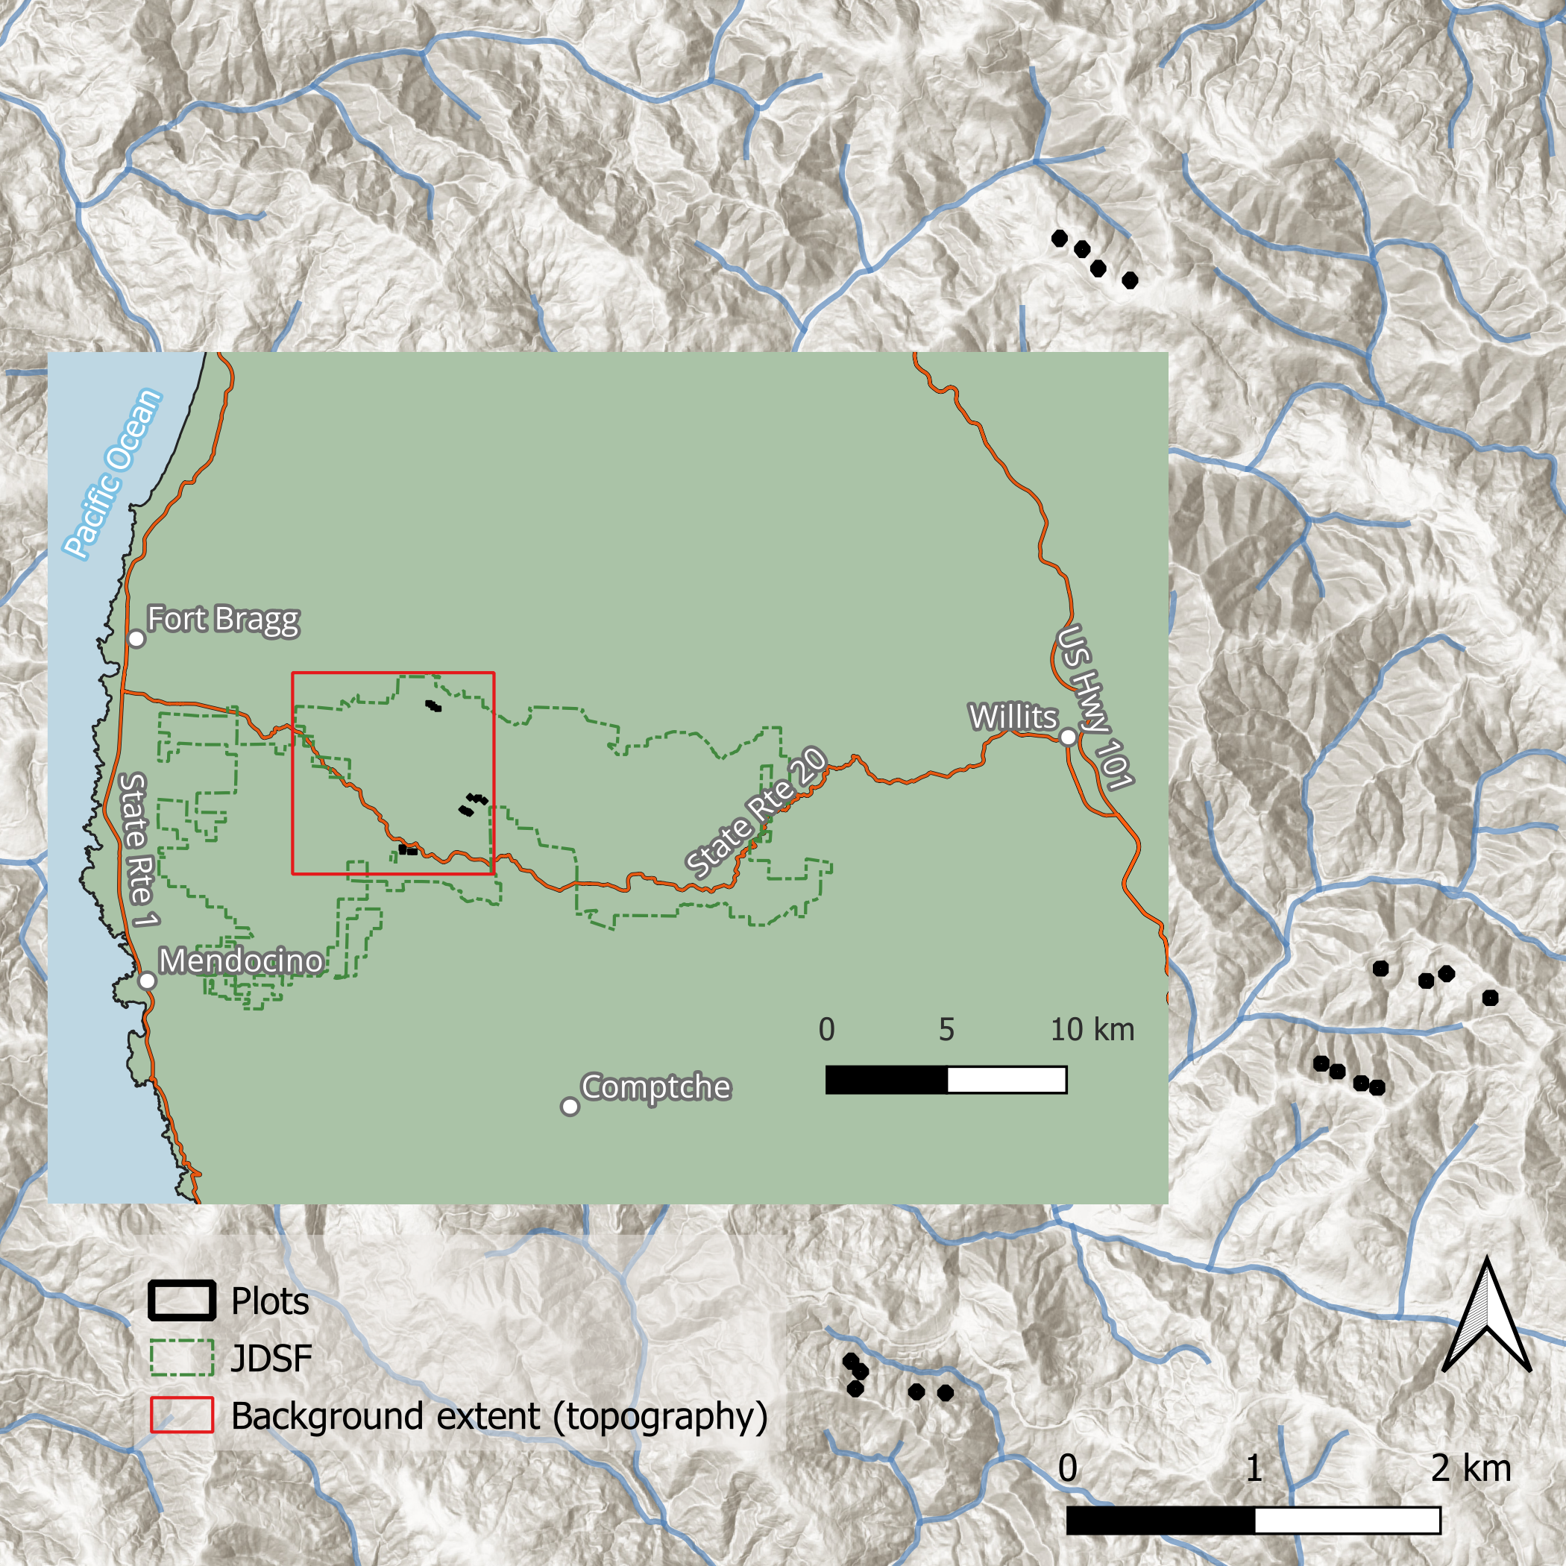
Figure 2.1: The site locations and topography for our study plots. The red box delineates the area of the topographical map seen in the background. JDSF = Jackson Demonstration State Forest.

2.2 Study design
In 2012, four treatments were replicated at four different sites. The treatments were: group selection (GS), high-density dispersed retention (HD), high-density aggregated retention (HA), and low-density dispersed retention (LD). The GS treatment is composed of a circular 1-ha opening in which all trees were removed, surrounded by a 50-meter buffer of light thinning in which less than 1/3 of the basal area was removed. The remaining treatments were applied over 2-hectare treatment units. The target post-harvest density was specified in terms of relative stand density index (SDI) using an assumed upper SDI limit for redwood of 2,470 stems ha⁻¹ (Reineke, 1933). The target residual relative density for the HA and HD treatments was 21% (SDI = 520), and the for the LD treatment it was 13% (SDI = 320). These densities were chosen to balance the objectives of stand volume productions and individual tree growth assuming a subsequent, similar harvest after 20 years (Berrill & O’Hara, 2009).
After harvesting, 0.2-hectare square macro plot was established in the center of each treatment unit. Approximately 25 redwood and 25 tanoak sprout clumps that were well distributed across the plot, were selected for measurement. Additionally, for redwood, sprout clumps were selected evenly from those with, and without residual standing trees.
Ten years after the initial harvest regeneration plots and fuel transects were established within the macro plot (Figure 2.2). Circular regeneration plots with a 4-meter radius were established 10 meters from each macro plot corner, towards the plot center. Terminating at the center of each of these regeneration plots, 10-meter fuel transects were established parallel to the macro plot edges. Live fuels were estimated in 1-meter radius “sampling cylinders” at the five-, and nine-meter locations along each transect.
Following year 10 measurements, all plots received a pre-commercial thinning treatment where the objective was to release merchantable conifers such as redwood and Douglas-fir from competition. Competing trees and shrubs were cut, lopped, and scattered within the measurement plots and fuel transects were re-measured.
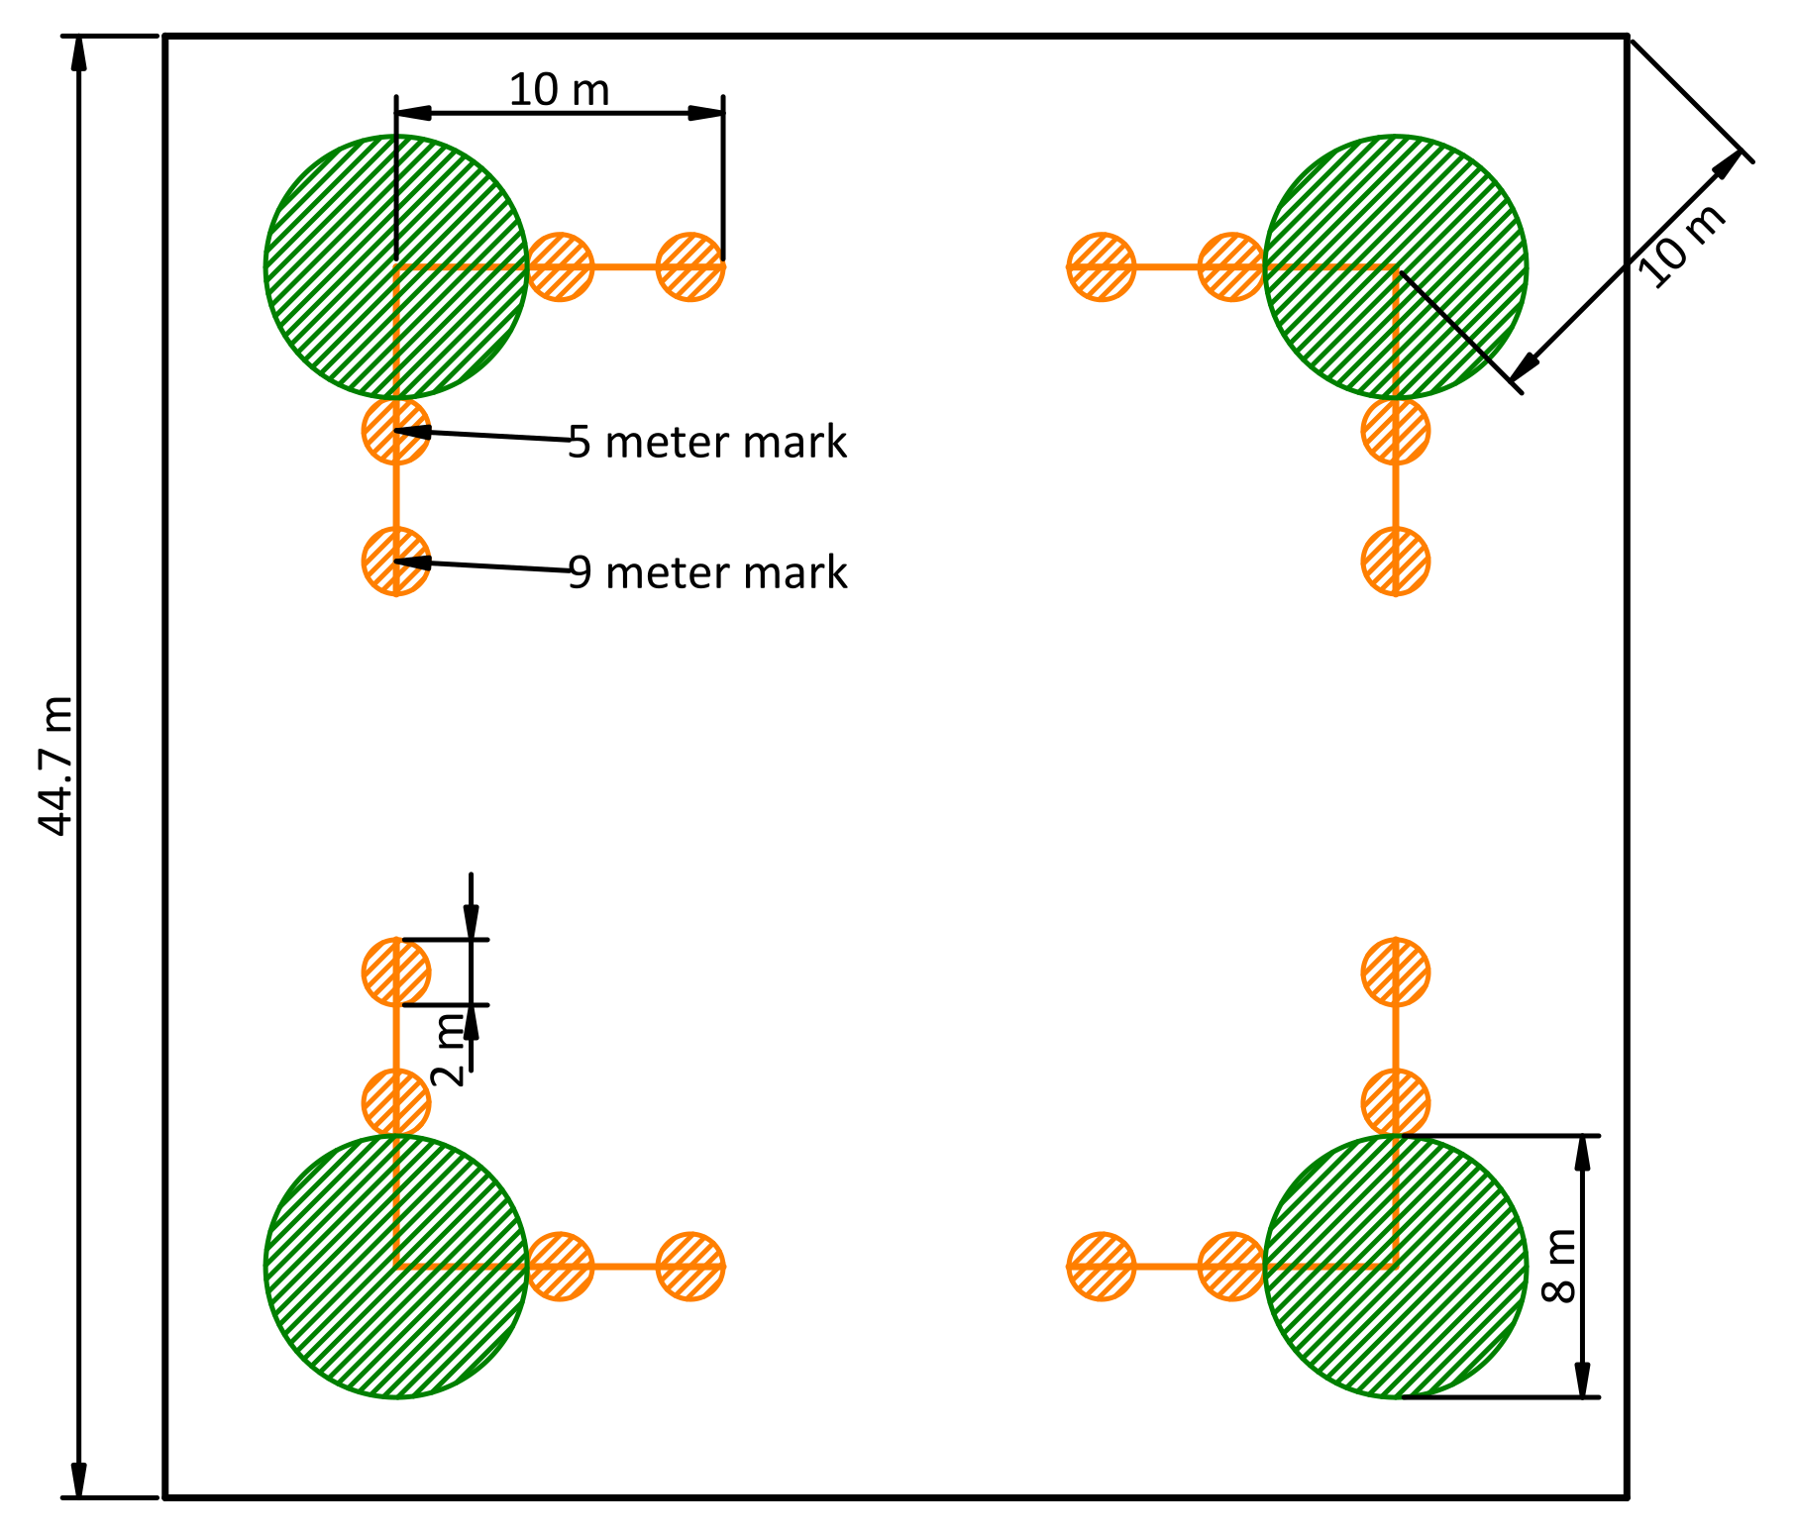
Figure 2.2: A diagram of the fuel sampling design depicting a 0.2-hectare macro plot (black outline), fuels transects (black lines), sampling cylinders (orange circles) where duff, litter, and live and dead vegetation were measured, and vegetation sub-plots (green circles), where regeneration density and diversity were quantified.

2.3 Data collection

2.3.1 Sprout size
Sprout height data were collected during the winter at years 1, 5, and 10 following the initial harvest. Sprout heights at each period were based on the tallest individual within a clump at the time of measurement with a height pole placed at the same location on the ground at each measurement period. The observer eliminated parallax by observing from a location up-slope, level with the height of the sprout. Sprout DBH for only redwood was collected in year 10.

2.3.2 Regeneration
Ten years after the initial harvest, four four-meter-radius regeneration plots were established within each macro plot (Figure 2.2). All regenerating trees (sprouts and seedlings) within the plot were recorded. Regenerating trees less than 5 cm at breast height (1.4 m) were tallied by 2.5 cm size classes and the actual DBH of all other regenerating trees were recorded. This allowed for an estimation of sprout and seedling density.

2.3.3 Fuels
Also at 10 years after the initial harvest, fuel transects were established and sampled according to the FIREMON protocol (Lutes et al., 2006), with some adaptations that were unique to this project. This protocol is very similar to that of Brown (1974). One-, 10-, 100-hr, and 1000-hr (or coarse woody) fuels were those less than 0.635 cm, 0.635 to 2.54 cm, 2.54 to 7.62 cm and those 7.62 cm and greater, respectively and included only dead and downed woody fuels (not those attached to live vegetation, or standing dead). Transect lengths for 1-, 10-, and 100-hr fuels were one, two, and four meters, respectively. Coarse woody fuels were measured along the entire 10-meter transect.
Redwoods, like other species in Cupressaceae, shed branchlets instead of individual leaves. This leads to difficulty in distinguishing “litter” from 1-hr fuels. We chose to use an estimated cutoff of about 2 mm for redwoods sprays where larger pieces were considered 1-hr fuel and smaller pieces were considered part of the litter layer. We did not distinguish between “leafy” and “awl like” leaf shapes (Graham, 2009).
Live vegetation percent cover and average height were estimated in 1-meter-radius “sampling cylinders” as described in the FIREMON protocol (Lutes et al., 2006). A notable exception is that the sampling cylinders were allowed to extend to the (average) top height of the live fuels that were continuous within less than a meter of the ground. This resulted in average live vegetation heights that could sometimes reach near the height of the sprouts and average heights above two meters were estimated with the help of a clinometer. This decision makes explicit instances when when fuels are vertically continuous with the ground. Live vegetation percent cover was estimated for four vegetation classes: live woody fuels, dead woody fuels, live herbaceous fuels, and dead herbaceous fuels. Dead “live” fuels includes dead fuels attached to live plants, or those still rooted in the ground. Particles in these conditions are not counted as downed woody fuels when tallying fine and coarse woody fuels along fuel transects. These fuels are, though, expected to behave differently during combustion than live “live” fuels. Average vegetation height was recorded for two classes: the average height of all woody fuels and the average height of all herbaceous fuels. These estimates pertain to the particles present in the sampling cylinder, and not the area-average, thus a cylinder with only one percent cover, could still have an average height of two meters, i.e., the empty space within the cylinder does not affect the average height. The average height and percent-cover estimates are visual estimations and efforts were made to discuss these frequently to ensure that estimates among observers were consistent. Percent cover estimates were discrete, rounded to the nearest class in the set: 0.5, 3, 10, and all subsequent 10 percent increments up to 100 percent.
The depth of duff and litter was measured at one representative location within each of the two, 1-meter-radius sampling cylinders along each transect. When duff and litter conditions varied greatly in a single sampling cylinder, a location was chosen to represent the average of conditions within the cylinder.
Fuel bed depth was estimated as the average height of the fine and coarse woody debris components within each sampling cylinder. Theoretically, this included litter, but now duff. This estimate was not described in the FIREMON protocol, but it was designed to be made in a similar manner as described for vegetation heights.

2.4 Analysis
An analysis was conducted in three stages, one for each of the three response categories: fuels, sprout size, and regeneration density. All analyses were conducted using R and attempts were made to document all data, decisions, and techniques within a Quarto notebook, which is published at https://fisher-j.github.io/multi-age. All response variables were analyzed using multi-level models to account for the inherent nesting structure of the data, including multiple measurements of individuals over time, where applicable. Grouping levels were included in the models if their variance estimate was determined to be significant based on the size of the variance and the magnitude that inclusion of that grouping level had on the estimates and their corresponding confidence levels. Because the overall objective was to detect differences between treatments, treatment was used as the primary independent variable. Model development and selection were carried out using Akaike information criterion, Bayesian information criterion, and visualization of (probability integral) transformed residuals (Hartig, 2022). Models were built using the R package GLMMtmb, which provides a consistent framework for exploring different response distributions and link functions as well as the ability to model variance as a function of predictors (Brooks et al., 2017). The final model structures chosen for each response are given in the results section.
Models were interpreted using estimated marginal means calculated with the R packages marginaleffects and emmeans (Arel-Bundock et al., 2024; Lenth, 2021). Predictions incorporating the effects of all model components were made on the response scale for a grid of predictors consisting of all unique combinations of factors in the data that were used in at least one component of a given model (we didn’t have numeric predictors) except in the case of tree heights where predictions were made for each observation in the data set. Standard errors for the predictions were calculated using the delta method. Predictions were averaged across non-focal predictors (especially “random” effects) to obtain the population estimates of marginal means. These means are expected to be applicable to other treatments when conducted across equal proportions of sites with conditions similar to those used in our study. Notably, our population estimates assume equal proportions of north and south facing aspects.
 | TODO:  - what kind of predictions am I using, are they unit level or population level predictions?  - How and when are predictions back-transformed to the response scale from the link scale?  - Are these conditional predictions? Conditioned on what? Or are they marginal predictions? (heissMarginalConditionalEffects?)  - I would like to write my models in formal notation similar to (heissMarginalConditionalEffects?):  $$\begin{matrix}\text{lifeExp} & ∼N\left(μ_{i_{j}},σ_{y}\right) & \text{Life expectancy within countries }j \\ μ_{i_{j}} & =\left(β_{0}+b_{0_{j}}\right)+β_{1} {\text{gdpPercap}}_{i_{j}} & \text{Model of within-country variation} \\ b_{0_{j}} & ∼N\left(0,σ_{0}\right) & \text{Random country offsets from global average}\end{matrix}$$

2.4.1 Fuels
Fuel load in Mg ha⁻¹ was estimated for 1-hr, 10-hr, 100-hr, combined duff and litter (“duff/litter”), 1,000-hr, and live vegetation fuels at the transect level. Any transect where a fuel type was not observed was assigned a value of zero for that class and transect. Fuel load for 1- through 1,000-hr fuels were calculated using the method in Brown (1974). The required size-class specific parameters (specific gravity, particle inclination, and average diameter) were derived from a previous study where I used parameters averaged across all of the measured plots (Glebocki, 2015). For 1,000-hr fuels, decay classes 1-3 were considered “sound” and decay classes 4 and 5 were considered “rotten” for the purpose of calculating load and these loads were combined. Duff and litter were measured at two locations along each transect and these were averaged at the transect level. We did not measure the bulk density of duff and litter fuels, but based on findings in other studies in the redwood region, we opted to combine these classes into a single fuel class, using an average bulk density found across those studies of 7.73 Mg ha⁻¹ (Finney & Martin, 1993a; Kittredge, 1940; Stuart, 1985). Vegetation fuel load was calculated using bulk density constants of 8 Mg ha⁻¹ m⁻¹ for herbaceous fuels and 18 Mg ha⁻¹ m⁻¹ for woody components (Gangi, 2006). Live and dead components were combined to calculate herbaceous and woody loading and these loadings were combined and averaged at the transect level (again there were two measurements per transect) to determine total vegetation loading. Herbaceous fuel loading was generally very low.

2.4.2 Sprout heights
Two metrics were analyzed from the sprout height data: height increment (m year⁻¹), and total height (m) at year 10. For height increment, there were two measurements for each tree: increment for years 1 to 5 and increment for years 5 to 10. Thus, analysis of this data included tree as a candidate random effect. While not making a difference for analysis results, it is worth noting that this data was structured differently from the other datasets in that plot was made a globally unique identifier, thus making explicit the nesting of plots within sites or treatments and eliminating the need to specify this nesting structure in the R code model formulas.

2.4.3 Regeneration density
Sprout census data from our 4-meter-radius regeneration plots were converted to basal area per acre per species. Tallies of species by size class for sprouts less than 5 cm dbh were converted to diameters using the class midpoint (1.27 or 3.81 cm) before calculating basal area per acre. Minor species (e.g., those other than redwood, tanoak, and Douglas-fir) were combined into an “other” category. Missing species on a plot were made explicit by assigning a value of 0 m² ha⁻¹ for that species and plot. In addition to basal area, Douglas-fir stem counts (stems ha⁻¹) were modeled separately.

3. Results

3.1 Regeneration composition

3.1.1 Basal area
Composition of regeneration in terms of basal area per acre represented by each species in a 4-meter radius vegetation plot was modeled as a gamma distribution with a log link with fixed effects for treatment and species, and random intercepts for site x species interaction. Dispersion was modeled separately as a function of species, using a log link and the rate of zeros was modeled using the logit link, for each species as well (Listing 3.1).
Listing 3.1
Family: Gamma (log)
Conditional: ba_ha ~ treat * spp + (1 | site:spp)
Dispersion: ~spp (log)
Hurdle: ~spp (logit)
Adding missing grouping variables: `spp`
Adding missing grouping variables: `spp`
Adding missing grouping variables: `spp`
According to predictions made from this model, there was not enough evidence to confirm a statistically significant difference between treatments. On average, we expect about 0.11 m² ha⁻¹ of basal area across treatments. The greatest basal area of other species was in the HD treatment which was 0.12 m² ha⁻¹ greater than in the HA treatment (p = 0.26). The GS and LD treatments were intermediate.
On average, for Douglas-fir, we expect about 0.17 m² ha⁻¹ of basal area across treatments. The greatest basal area of Douglas-fir was in the GS treatment which was 0.12 m² ha⁻¹ greater than in the HA treatment (p = 0.76). The LD, HA, and HD treatments were all comparatively similar.
Redwood basal area regeneration showed the greatest treatment response. Where the GS treatment had the greatest basal area of redwood regeneration at m² ha⁻¹, which was 9.28 m² ha⁻¹ greater than in the HD treatment (p = 0.19). The LD and HD treatments were intermediate.
Tanoak basal area regeneration was intermediate between that of redwood and Douglas-fir and other species. The GS and LD treatments had similar responses, as did the HA and HD treatments. The GS treatment resulted in 2.24 m² ha⁻¹ of tanoak basal area, which was 1.33 m² ha⁻¹ greater than in the HA treatment (p = 0.18).
Table 3.1: Grand means (m² ha⁻¹) for basal area of regeneration of each species across treatments 10 years after the initiation of a multi-age redwood forest.
spp | 1 | estimate | SE | df | asymp.LCL | asymp.UCL
other | overall | 0.11 | 0.04 | Inf | 0.03 | 0.19
df | overall | 0.17 | 0.06 | Inf | 0.05 | 0.28
rw | overall | 4.03 | 1.52 | Inf | 1.04 | 7.01
to | overall | 1.59 | 0.47 | Inf | 0.67 | 2.50

Adding missing grouping variables: `spp`
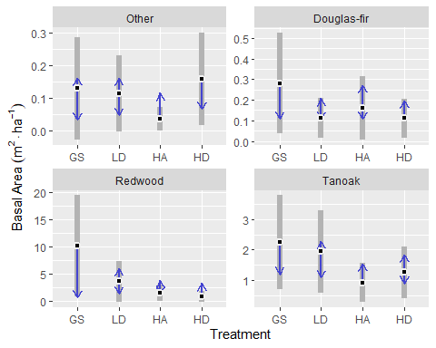
Figure 3.1: Basal area (m² ha⁻¹) modeled at the vegetation plot level for four harvest treatments and four species classes (n = 16). Gray bars represent the 95% confidence interval (α = 0.05), black dots indicate the mean, and blue arrows provide a means of assessing the statistical significance of pairwise differences among treatments. Arrows are drawn so that when two arrows just meet, the p-value for that difference is 0.05 and overlapping arrows indicate a p-values greater than 0.05.
Adding missing grouping variables: `spp`
Table 3.2: Basal area (m² ha⁻¹) modeled at the vegetation plot level for four harvest treatments and four species classes (n = 16).
spp | treatment | estimate | SE | df | asymp.LCL | asymp.UCL
other | gs | 0.13 | 0.08 | Inf | -0.03 | 0.29
other | ld | 0.11 | 0.06 | Inf | -0 | 0.23
other | ha | 0.04 | 0.02 | Inf | -0 | 0.07
other | hd | 0.16 | 0.07 | Inf | 0.02 | 0.3
df | gs | 0.28 | 0.12 | Inf | 0.04 | 0.52
df | ld | 0.11 | 0.05 | Inf | 0.02 | 0.21
df | ha | 0.16 | 0.08 | Inf | 0.01 | 0.31
df | hd | 0.11 | 0.05 | Inf | 0.01 | 0.21
rw | gs | 10.12 | 4.74 | Inf | 0.84 | 19.41
rw | ld | 3.63 | 1.91 | Inf | -0.12 | 7.38
rw | ha | 1.51 | 0.78 | Inf | -0.01 | 3.04
rw | hd | 0.85 | 0.52 | Inf | -0.17 | 1.86
to | gs | 2.24 | 0.79 | Inf | 0.7 | 3.79
to | ld | 1.94 | 0.69 | Inf | 0.58 | 3.3
to | ha | 0.92 | 0.33 | Inf | 0.28 | 1.56
to | hd | 1.25 | 0.44 | Inf | 0.39 | 2.11

Adding missing grouping variables: `spp`
Table 3.3: Pairwise comparisons of treatments within species. P-values are adjusted using the Tukey method for comparing families of four estimates.
spp | contrast | estimate | SE | df | p.value
other | gs - ld | 0.02 | 0.09 | Inf | 1
other | gs - ha | 0.09 | 0.08 | Inf | 0.6
other | gs - hd | -0.03 | 0.09 | Inf | 0.99
other | ld - ha | 0.08 | 0.06 | Inf | 0.53
other | ld - hd | -0.04 | 0.07 | Inf | 0.91
other | ha - hd | -0.12 | 0.07 | Inf | 0.26
df | gs - ld | 0.17 | 0.11 | Inf | 0.46
df | gs - ha | 0.12 | 0.12 | Inf | 0.76
df | gs - hd | 0.17 | 0.11 | Inf | 0.42
df | ld - ha | -0.05 | 0.08 | Inf | 0.93
df | ld - hd | 0 | 0.05 | Inf | 1
df | ha - hd | 0.05 | 0.07 | Inf | 0.91
rw | gs - ld | 6.49 | 4.6 | Inf | 0.49
rw | gs - ha | 8.61 | 4.56 | Inf | 0.23
rw | gs - hd | 9.28 | 4.64 | Inf | 0.19
rw | ld - ha | 2.12 | 1.8 | Inf | 0.64
rw | ld - hd | 2.79 | 1.83 | Inf | 0.42
rw | ha - hd | 0.67 | 0.79 | Inf | 0.83
to | gs - ld | 0.31 | 0.69 | Inf | 0.97
to | gs - ha | 1.33 | 0.65 | Inf | 0.18
to | gs - hd | 0.99 | 0.64 | Inf | 0.4
to | ld - ha | 1.02 | 0.58 | Inf | 0.29
to | ld - hd | 0.69 | 0.57 | Inf | 0.63
to | ha - hd | -0.33 | 0.37 | Inf | 0.8

Adding missing grouping variables: `treat`
Adding missing grouping variables: `treat`
Figure 3.2 shows the same model as Figure 3.1, but with an emphasis on treatment comparisons between redwood and tanoak. This shows that we expect on average, 7.88 m² ha⁻¹ greater redwood basal area than tanoak basal area in the GS treatment (p = 0.1), about 1.69 m² ha⁻¹ in the LD treatment (p = 0.4), and about 0.6 m² ha⁻¹ in the HA treatment (p = 0.48). In the HD treatment, we expect to see slightly higher tanoak basal area (0.55).
Uncertainty in average Redwood basal area across sites, indicated by the size of 95% confidence intervals, is much greater than that of tanoak in the GS treatment, but this difference diminishes such that GS > LD > HA > HD. In the HD treatment redwood and tanoak average basal area uncertainty across sites is very similar. (Figure 3.1).
Adding missing grouping variables: `treat`
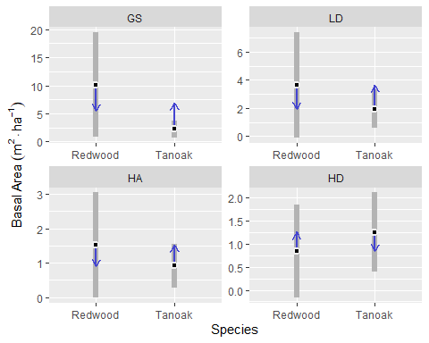
Figure 3.2: Basal area (m² ha⁻¹) modeled at the vegetation plot level for four harvest treatments and two species classes (n = 16). Gray bars represent the 95% confidence interval, black dots—the mean, and non-overlapping blue arrows signify statistical significance (α = 0.05).

3.1.2 Other species
Other species included grand fir, madrone, and California wax-myrtle, of which there was a total of 23, 28, and 16 observations across our 16 macro plots (comprising 64 tree density plots). Generally, each plot had between 0 and 9 observations of other species, except for one macro plot with the LD treatment, which had 16 observations (data not shown).

3.1.3 Douglas-fir counts
Counts of regenerating Douglas-fir seedlings per vegetation plot (n = 16) were analyzed for differences between harvest treatments using a negative binomial response with a log link, fixed effects for treatment, random effects for site and site x treatment interaction (Listing 3.2).
Listing 3.2
Family: nbinom1 (log)
Conditional: n ~ treat + (1 | site) + (1 | site:treat)
This model for Douglas-fir counts does not indicate any statistically significant differences between treatments. Generally, we expect about 2 seedlings per 4-meter-radius plot, or about 413 seedlings per hectare (Figure 3.3).
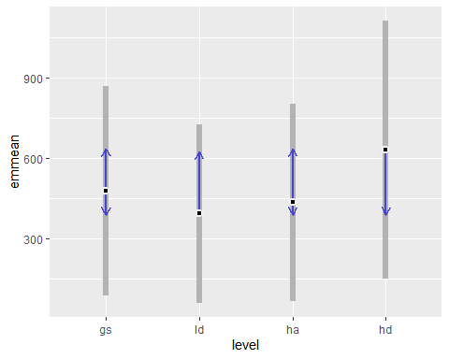
Figure 3.3: Vegetation plot level counts of regenerating Douglas-fir seedlings in four harvest treatments 10 years after harvest (n = 16). Results have been scaled to stems per hectare (4-meter radium plots).
Table 3.4: Vegetation plot level counts of regenerating Douglas-fir seedlings in four harvest treatments 10 years after harvest (n = 16). Results have been scaled to stems per hectare from 4-meter radium plots.
Treatment | estimate | asymp.LCL | asymp.UCL
gs | 479 | 88 | 869
ld | 394 | 60 | 728
ha | 435 | 65 | 805
hd | 632 | 149 | 1115

3.2 Sprout heights

3.2.1 Height increment
The selected height increment model used a normal response distribution on the identity link. It included treatment, growth period, species, and the interaction of species and growth period as fixed effects. A random intercept was included for tree (multiple observations) and macro-plot, and an another random effect allowed the response to vary by species differently for each macro plot. The dispersion parameter for the response was modeled (with a log link) as a function of treatment, growth period, species and all three-way interactions (Listing 3.3).
Listing 3.3
Family: gaussian (identity)
Conditional: ht_inc ~ treat + year * spp + (1 | tree) + (0 + spp | plot)
Dispersion: ~spp * year * treat (log)
Adding missing grouping variables: `spp`
Adding missing grouping variables: `spp`
The model selected based on AIC lacks a treatment x species interaction, suggesting that there is not evidence that treatments affected species differentially. It also lacks a treatment x year interaction. This means that there was not enough evidence to support that treatment was related to changes in growth rate.
The inclusion of treatment factors in the model (0.001 ≤ p < 0.03) suggests that the levels of treatment were associated with different growth rates across species and years. And the species x year interaction (p < 0.001) suggests changes in growth rates are different for redwood and tanoak (Figure 3.4).
For tanoak, height increment was greatest in the GS treatment at 0.48 m yr⁻¹. This was about 0.17 m yr⁻¹ more than in the HA and HD treatments, which were very similar at about 0.31, 0.03, , 0.24, 0.37 m yr⁻¹.
Redwood followed a similar pattern but with more pronounced differences between treatments. Height increment for redwood in the GS treatment was 0.96 m yr⁻¹, which was about 0.4 m yr⁻¹ greater than in the HD treatment (p = 0). Additionally, there was evidence that the GS treatment led to greater height increment than the LD treatment by about 0.17 m yr⁻¹ (p = 0). And the LD treatment was higher than the HA treatment by about 0.15 m yr⁻¹ (p = 0).
Adding missing grouping variables: `spp`
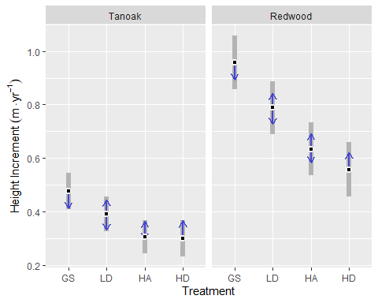
Figure 3.4: Estimated marginal means for the effect of harvest treatment on redwood and tanoak sprout height increment, averaged over two growth periods, ten years after harvest. Gray bars represent confidence intervals and statistical significance (α = 0.05) is indicated by non-overlapping blue arrows.
Adding missing grouping variables: `spp`
Table 3.5: Estimated marginal means for the effect of harvest treatment on redwood and tanoak sprout height increment, averaged over two growth periods, ten years after harvest.
spp | treatment | estimate | SE | df | asymp.LCL | asymp.UCL
LIDE | GS | 0.48 | 0.034 | Inf | 0.41 | 0.54
LIDE | LD | 0.39 | 0.033 | Inf | 0.32 | 0.46
LIDE | HA | 0.31 | 0.032 | Inf | 0.24 | 0.37
LIDE | HD | 0.3 | 0.034 | Inf | 0.23 | 0.37
SESE | GS | 0.96 | 0.052 | Inf | 0.86 | 1.06
SESE | LD | 0.79 | 0.051 | Inf | 0.69 | 0.89
SESE | HA | 0.63 | 0.05 | Inf | 0.54 | 0.73
SESE | HD | 0.56 | 0.052 | Inf | 0.46 | 0.66

Adding missing grouping variables: `spp`
Adding missing grouping variables: `spp`
Redwood growth slowed from 0.80 to 0.67 m yr⁻¹ in the second period and tanoak slowed from 0.39 to 0.34 m yr⁻¹.
Redwood grew faster than tanoak, but slowed down more relative to it in the second period. Height increment for redwood was 0.42 m yr⁻¹ greater than tanoak in the first period and 0.33 m yr⁻¹ greater than tanoak in the second period (Figure 3.5).
Adding missing grouping variables: `spp`
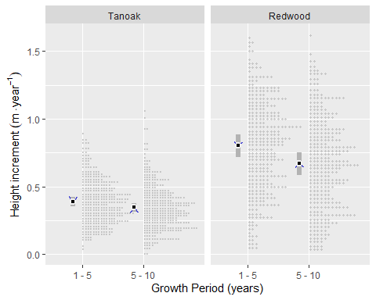
Figure 3.5: Estimated marginal means for the effect of growth period on redwood and tanoak sprout height increment, averaged over four harvest treatments, from years 1 to 5, and years 5 to 10 after harvest, plotted alongside actual data. Gray bars represent confidence intervals and statistical significance (α = 0.05) is indicated by non-overlapping blue arrows.
Adding missing grouping variables: `spp`
Table 3.6: Estimated marginal means for the effect of growth period on redwood and tanoak sprout height increment, averaged over four harvest treatments, from years 1 to 5, and years 5 to 10 after harvest.
spp | year | estimate | SE | df | asymp.LCL | asymp.UCL
LIDE | 5 | 0.39 | 0.017 | Inf | 0.35 | 0.42
LIDE | 10 | 0.35 | 0.017 | Inf | 0.31 | 0.38
SESE | 5 | 0.8 | 0.043 | Inf | 0.72 | 0.89
SESE | 10 | 0.67 | 0.043 | Inf | 0.59 | 0.75

3.2.2 Height at year 10
Sprout heights at year 10 were modeled with a normal response and a log link. The best model included species and treatment, but no interactions in the fixed effects. This suggests that treatments do not affect species differentially in terms of the mean response (height at year 10). It also included a model for dispersion (log link) with predictors species, treatment, and their interaction (Listing 3.4).
Listing 3.4
Family: gaussian (log)
Conditional: ht ~ treat + spp + (0 + spp | plot)
Dispersion: ~spp * treat (log)
Adding missing grouping variables: `spp`
Adding missing grouping variables: `spp`
Because the best model did not contain a species x treatment interaction for the mean response, treatment comparisons are parallel between species. The GS treatment resulted in greater heights in year 10 than the other treatments (0.001 < p < 0.05). Predicted mean height for redwood ranged from 10.64 m in the GS treatment to 6.3 m in the HD treatment. For tanoak, predicted mean height ranged from 5.2 in the GS treatment to 3.08 in the HD treatment. Predicted mean heights followed the pattern GS > LD > HA > HD (Figure 3.6).
Adding missing grouping variables: `spp`
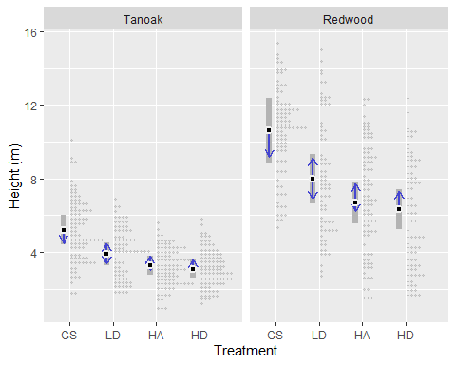
Figure 3.6: Predicted mean height and 95% confidence intervals (gray bars) for redwood and tanoak stump sprouts 10 years after harvest using four different harvest treatments. Non-overlapping blue arrows indicate statistically significant differences between treatments within a species.
Adding missing grouping variables: `spp`
Table 3.7: Height (m) of measured redwood and tanaok sprouts 10 years after harvest treatments with four different over-story densities.
spp | year | estimate | SE | df | asymp.LCL | asymp.UCL
LIDE | GS | 5.2 | 0.41 | Inf | 4.4 | 6
LIDE | LD | 3.9 | 0.31 | Inf | 3.3 | 4.5
LIDE | HA | 3.3 | 0.27 | Inf | 2.8 | 3.8
LIDE | HD | 3.1 | 0.25 | Inf | 2.6 | 3.6
SESE | GS | 10.6 | 0.9 | Inf | 8.9 | 12.4
SESE | LD | 8 | 0.69 | Inf | 6.6 | 9.3
SESE | HA | 6.7 | 0.59 | Inf | 5.5 | 7.8
SESE | HD | 6.3 | 0.55 | Inf | 5.2 | 7.4

Adding missing grouping variables: `spp`
Table 3.8: Pairwise comparisons of treatments within species for height (m) of measured redwood and tanoak sprouts 10 years after harvest.
spp | contrast | estimate | SE | df | p.value
LIDE | GS - LD | 1.3 | 0.5 | Inf | 0.05
LIDE | GS - HA | 1.93 | 0.48 | Inf | 0
LIDE | GS - HD | 2.12 | 0.47 | Inf | 0
LIDE | LD - HA | 0.63 | 0.4 | Inf | 0.4
LIDE | LD - HD | 0.82 | 0.39 | Inf | 0.16
LIDE | HA - HD | 0.19 | 0.36 | Inf | 0.95
SESE | GS - LD | 2.66 | 1.03 | Inf | 0.05
SESE | GS - HA | 3.94 | 0.98 | Inf | 0
SESE | GS - HD | 4.33 | 0.97 | Inf | 0
SESE | LD - HA | 1.29 | 0.82 | Inf | 0.4
SESE | LD - HD | 1.68 | 0.81 | Inf | 0.16
SESE | HA - HD | 0.39 | 0.75 | Inf | 0.95

3.3 Fuels

3.3.1 Pre-pct
Gamma distributed, linear multi-level models, with a log link were used for all six fuel class responses. Random intercepts were specified for three levels of nesting, representing sites, treatment blocks, and transect corners. All models except for the duff & litter model included a hurdle model to account for zero, which was modeled with a logit link. For the 10-hr fuel model, the hurdle portion was modeled as a function of treatment, and for the others, it was modeled as a single rate for all observations. The 10-hr fuel model also included a dispersion model, which was modeled with a log link, using treatment as a predictor (Table 3.9).
Table 3.9: Model specifications for six fuel classes before pct.
class | Family | Link | Conditional | Dispersion (log) | Hurdle (logit)
Duff & Litter | Gamma | log | load ~ treatment + (1 | site) + (1 | block) + (1 | corner) | ~1 | ~0
1-hr | Gamma | log | load ~ treatment + (1 | site) + (1 | block) + (1 | corner) | ~1 | ~1
10-hr | Gamma | log | load ~ treatment + (1 | site) + (1 | block) + (1 | corner) | ~treatment | ~treatment
100-hr | Gamma | log | load ~ treatment + (1 | site) + (1 | block) + (1 | corner) | ~1 | ~1
1,000-hr | Gamma | log | load ~ treatment + (1 | site) + (1 | block) + (1 | corner) | ~1 | ~1
Vegetation | Gamma | log | load ~ treatment + (1 | site) + (1 | block) + (1 | corner) | ~1 | ~1

TODO: I’m here
For Duff & Litter, the largest difference was between the HD and HA treatments. The HD treatment had about 1.4 times more duff and litter (p = 0.07). Generally, all treatments were similar, with estimated loading of around 50 Mg ha-1. One-hour fuels were around 50% higher in the HA treatment compared to the LD and GS treatments (p = 0.07, and p = 0.01, respectively), with mean differences of around 0.5 Mg ha-1. Ten, hundred and thousand-hour fuels were statistically, very similar across treatments (p = 0.7 — p = 1). Point estimates varied by about 1, 3, and <20 Mg ha-1 for ten, hundred, and thousand-hour fuels, respectively. Vegetative fuel loading was greatest in the GS treatment, with an expected value of 28.5 Mg ha-1, which was about 2.7 times greater than in HA (p = 0.01) (Figure 3.7).
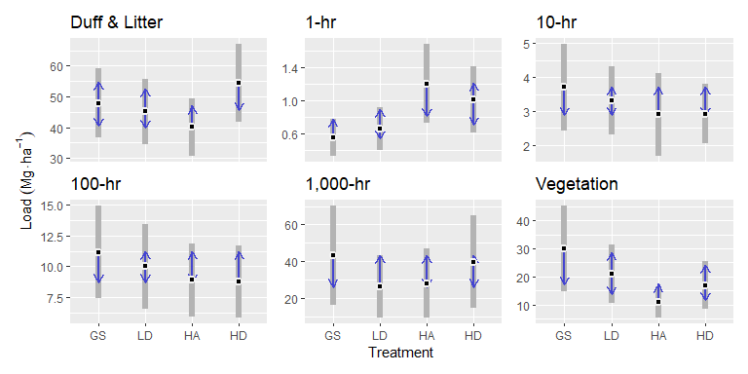
Figure 3.7: Estimated marginal means (black dots) confidence intervals (gray bands) and comparisons (blue arrows) of fuel loading across four treatments for six different fuel-class models. Non-overlapping blue arrows indicates statistical significance at the α = 0.05 level.
Table 3.10: Estimated marginal means (Mg ha⁻¹) for six fuel classes and four overstory treatments before pct
class | treatment | estimate | SE | df | asymp.LCL | asymp.UCL
dufflitter | gs | 47.93 | 5.69 | Inf | 36.76 | 59.09
dufflitter | ld | 45.09 | 5.35 | Inf | 34.6 | 55.59
dufflitter | ha | 40.01 | 4.75 | Inf | 30.71 | 49.32
dufflitter | hd | 54.4 | 6.46 | Inf | 41.74 | 67.06
onehr | gs | 0.55 | 0.11 | Inf | 0.33 | 0.77
onehr | ld | 0.66 | 0.13 | Inf | 0.4 | 0.92
onehr | ha | 1.2 | 0.24 | Inf | 0.73 | 1.68
onehr | hd | 1.01 | 0.2 | Inf | 0.61 | 1.41
tenhr | gs | 3.71 | 0.65 | Inf | 2.43 | 4.98
tenhr | ld | 3.31 | 0.52 | Inf | 2.3 | 4.32
tenhr | ha | 2.9 | 0.63 | Inf | 1.68 | 4.13
tenhr | hd | 2.91 | 0.45 | Inf | 2.04 | 3.79
hundhr | gs | 11.17 | 1.92 | Inf | 7.41 | 14.93
hundhr | ld | 10.03 | 1.76 | Inf | 6.58 | 13.47
hundhr | ha | 8.9 | 1.52 | Inf | 5.92 | 11.88
hundhr | hd | 8.76 | 1.49 | Inf | 5.84 | 11.69
thoushr | gs | 43.08 | 13.84 | Inf | 15.95 | 70.22
thoushr | ld | 26.25 | 8.58 | Inf | 9.43 | 43.06
thoushr | ha | 28.06 | 9.58 | Inf | 9.29 | 46.83
thoushr | hd | 39.75 | 12.94 | Inf | 14.38 | 65.11
veg | gs | 29.94 | 7.78 | Inf | 14.69 | 45.19
veg | ld | 20.88 | 5.32 | Inf | 10.45 | 31.3
veg | ha | 10.99 | 2.86 | Inf | 5.39 | 16.6
veg | hd | 16.86 | 4.32 | Inf | 8.4 | 25.32

Table 3.11: Grand means (Mg ha⁻¹) for six fuel classes before pct.
class | 1 | estimate | SE | df | asymp.LCL | asymp.UCL
dufflitter | overall | 46.86 | 4.21 | Inf | 38.6 | 55.1
onehr | overall | 0.86 | 0.12 | Inf | 0.63 | 1.1
tenhr | overall | 3.21 | 0.28 | Inf | 2.65 | 3.8
hundhr | overall | 9.71 | 1.1 | Inf | 7.56 | 11.9
thoushr | overall | 34.29 | 6.31 | Inf | 21.93 | 46.6
veg | overall | 19.67 | 3.52 | Inf | 12.77 | 26.6

3.3.2 Post-pct
The response for all six, post-pct fuel classes were modeled with a gamma distribution and a log link, and included the same multi-level random effects as for the pre-pct models. Dispersion models with treatment as the only predictor were included for 1-hr and 100-hr fuel classes. All models included a hurdle portion to model zeros using a logit link. For 100-hr fuels, this model included treatment and site as predictors, and for the rest, a constant rate for all observations was used (Table 3.12).
Table 3.12: Model specifications for six fuel classes after pct.
class | Family | Link | Conditional | Dispersion (log) | Hurdle (logit)
1-hr | Gamma | log | load ~ treatment + (1 | site) + (1 | block) + (1 | corner) | ~treatment + site | ~1
10-hr | Gamma | log | load ~ treatment + (1 | site) + (1 | block) + (1 | corner) | ~1 | ~1
100-hr | Gamma | log | load ~ treatment + (1 | site) + (1 | block) + (1 | corner) | ~treatment + site | ~treatment + site
1,000-hr | Gamma | log | load ~ treatment + (1 | site) + (1 | block) + (1 | corner) | ~1 | ~1
Vegetation | Gamma | log | load ~ treatment + (1 | site) + (1 | block) + (1 | corner) | ~1 | ~1
Vegetation Difference | Gamma | log | load ~ treatment + (1 | site) + (1 | block) + (1 | corner) | ~1 | ~1

Post-pct resulted in greater stratification of treatments (Figure 3.8). One-hour fuels for most treatments were around 2.4 Mg ha⁻¹, but the HA treatment had around half of that amount (p = 0.01 to p = 0.02). The GS treatment had the greatest 10-hr fuel loading with 8.8 Mg ha⁻¹, which was about 1.6, 2.3 and 2.9 times greater than the LD, HA, and HD treatments respectively (p = 0.03, p < 0.001, for the others, respectively). The LD treatment also had about 1.7 times more 10-hr fuels that the HD treatment (5.4 vs. 3 Mg ha⁻¹, p = 0.001). Hundred-hour fuels were also greatest in the GS treatment, with an average of about 19 Mg ha⁻¹, which was about 2.6 times greater than in the HD treatment (7 Mg ha⁻¹, p < 0.001). Thousand-hour fuels were greatest in the HD treatment, with 80 Mg ha⁻¹, which was about 2.7 times greater than the LD and HD treatments (p = 0.03 and p = 0.05, respectively). Fuel loading for live vegetation was similar across treatments at around 2.5 Mg ha⁻¹. The pre-post vegetation difference was greatest in the GS treatment at about 31 Mg ha⁻¹, which was 2.5 and 2.8 times the HD and HA treatments, respectively (p ≈ 0.01).
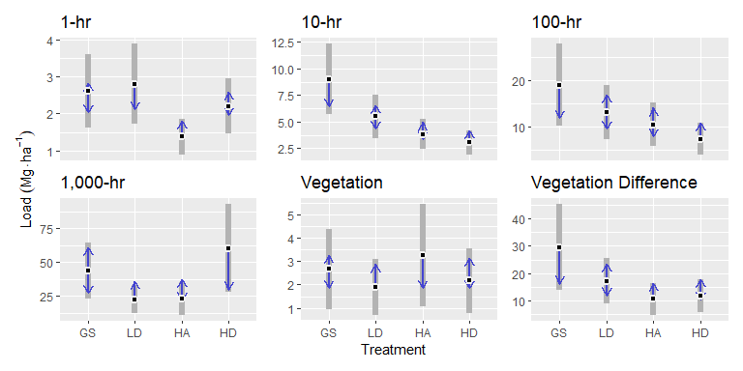
Figure 3.8: Estimated marginal means (black dots) confidence intervals (gray bars) and comparisons (blue arrows) of fuel loading across four treatments for six different fuel-class models. Non-overlapping blue arrows indicates statistical significance at the α = 0.05 level. Vegetation difference equals the transect level difference in vegetation load in the pre and post-pct conditions. This represents slash fuels recruited to the forest floor following the pre-commercial thinning.
Table 3.13: Estimated marginal means (Mg ha⁻¹) for six fuel classes and four overstory treatments before pct
class | treatment | estimate | SE | df | asymp.LCL | asymp.UCL
onehr | gs | 2.6 | 0.5 | Inf | 1.63 | 3.6
onehr | ld | 2.8 | 0.55 | Inf | 1.71 | 3.9
onehr | ha | 1.4 | 0.25 | Inf | 0.89 | 1.9
onehr | hd | 2.2 | 0.38 | Inf | 1.47 | 2.9
tenhr | gs | 9 | 1.7 | Inf | 5.68 | 12.3
tenhr | ld | 5.5 | 1.05 | Inf | 3.44 | 7.6
tenhr | ha | 3.9 | 0.73 | Inf | 2.41 | 5.3
tenhr | hd | 3.1 | 0.59 | Inf | 1.92 | 4.2
hundhr | gs | 19.1 | 4.52 | Inf | 10.26 | 28
hundhr | ld | 13.2 | 2.97 | Inf | 7.36 | 19
hundhr | ha | 10.5 | 2.41 | Inf | 5.81 | 15.3
hundhr | hd | 7.4 | 1.74 | Inf | 4.03 | 10.8
thoushr | gs | 43.9 | 10.61 | Inf | 23.08 | 64.7
thoushr | ld | 22.8 | 5.33 | Inf | 12.31 | 33.2
thoushr | ha | 23.2 | 6.21 | Inf | 11.04 | 35.4
thoushr | hd | 60.5 | 16.55 | Inf | 28.05 | 92.9
veg | gs | 2.7 | 0.87 | Inf | 0.96 | 4.4
veg | ld | 1.9 | 0.61 | Inf | 0.7 | 3.1
veg | ha | 3.2 | 1.12 | Inf | 1.06 | 5.4
veg | hd | 2.2 | 0.71 | Inf | 0.78 | 3.6
veg_diff | gs | 29.6 | 7.99 | Inf | 13.95 | 45.3
veg_diff | ld | 17.2 | 4.22 | Inf | 8.89 | 25.4
veg_diff | ha | 10.6 | 2.98 | Inf | 4.74 | 16.4
veg_diff | hd | 11.8 | 3.02 | Inf | 5.91 | 17.7

Table 3.14: Grand means (Mg ha⁻¹) for six fuel classes after pct.
class | 1 | estimate | SE | df | asymp.LCL | asymp.UCL
onehr | overall | 2.3 | 0.36 | Inf | 1.5 | 3
tenhr | overall | 5.4 | 0.84 | Inf | 3.7 | 7
hundhr | overall | 12.6 | 2.2 | Inf | 8.3 | 16.9
thoushr | overall | 37.6 | 5.61 | Inf | 26.6 | 48.6
veg | overall | 2.5 | 0.65 | Inf | 1.2 | 3.8
veg_diff | overall | 17.3 | 3.33 | Inf | 10.8 | 23.8

3.3.3 Pre-post commercial thinning comparison
Pre-commercial thinning led to a small increase in average 100-hr fuel loading, only for the GS treatment, increased 10-hr fuels in the GS and LD treatments, and increased 1-hr fuels for all but the HA treatment (Figure 3.9), although these results are not statistically comparable, due to slightly different model structures.
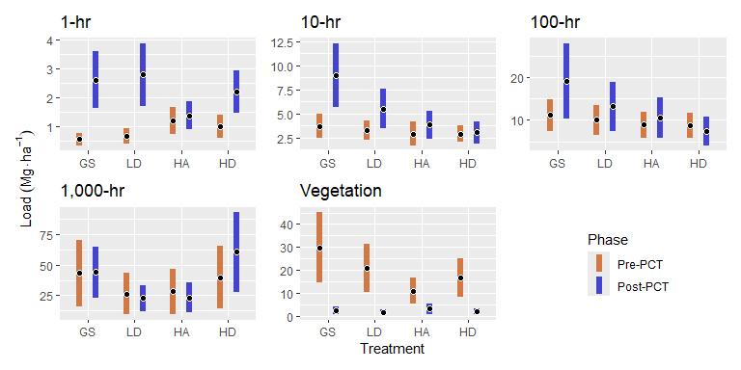
Figure 3.9: Estimated marginal means (black dots) and confidence intervals (colored bars) of fuel loading across four treatments and five different fuel classes, before and after PCT. Pre- and Post PCT models within a treatment are from similar, but not necessarily identical models.

4. Discussion
TODO
- Is the regularization imposed on our random effects for sites appropriate if the distribution of site effect is bi-modal because of north vs south facing aspects?
- Aspect is an important predictor that was not explicitly accounted for in our model, and may have led to inflated uncertainty
- GS and LD treatments were generally much harder to navigate in the field.
- Cost of treatments
- 1-hr redwood fuels differed from other studies in that we implemented a cutoff
- Discuss the decision to allow surface fuels to extend to greater than 2 meters
- similar bulk densities for duff and litter: Stuart. Also, Finney combined the two.
- Little is understood about tanoak sprout response under shade (Waring & O’Hara, 2008; Wilkinson et al., 1997), this study contributes to that knowledge describing a range of tanoak sprout development responses with varying overstory density.

4.1 Composition

4.1.1 Minor species
Our sampling included relatively few minor species and differences across treatments were small. The only statistically detectable difference occurred between the LD and HA treatment where the latter had less basal area of minor species. While this could be due to low numbers overall numbers of occurrences of minor species and high variability within treatments, this phenomena is corroborated by the low vegetation response found in the HA treatment for the separately gathered fuels data (Figure 3.7), as well as for tanoak sprout basal area where the only statistically supported evidence of treatment difference was between the GS and HA treatments. Potential differences in minor species abundance is likely only relevant for grand fir, due to its shade tolerance (Webb et al., 2012). Red alder and wester hemlock were observed earlier in this experiment, but were not detected with our current experimental design (R. T. Muma, 2019).
Douglas-fir is a minor species of special interest due to it’s commercial value and ability to compete with redwoods in the first 100 years of stand development (Wensel & Krumland, 1986). We didn’t detect statistically supported differences between treatments in terms of basal area (Figure 3.1) or stem counts (Figure 3.3). While our observed recruitment density of Douglas-fir seedlings may be sufficient for the eventual production of a viable cohort in a multi-aged system (Schütz and Röhnisch, 2003, as cited in Schütz & Pommerening, 2013), only the LD and GS treatments are likely to maintain overstory densities conducive to Douglas-fir seedling development (Miller & Emmingham, 2001; Schütz & Pommerening, 2013) given the overstory basal areas recorded at the initiation of the experiment (R. Muma et al., 2022). Rapidly developing redwood and tanoak sprouts will likely further comprise Douglas-fir seedlings competitive ability.

4.1.2 Redwood and tanoak
We found redwood growth in terms of average total basal area of sprouts 10 years after harvest treatment, responded strongly and positively to increasing levels of openness and the tanoak response was comparatively modest. This is expected based on traditional shade tolerance theory (Horn, 1971) and what is commonly understood of these two species (CITATIONS).
The only statistically justified difference for tanoak was between the GS and HA treatments. That we found slightly higher tanoak basal area in the HD treatment compared to the HA may be confounded by the fact that this treatment resulted in a greater number of tanaok stems less than 2.54 cm dbh (383 in HA vs 496 in HD, data not shown) and that this size class was assigned the perhaps inappropriate midpoint diameter of 1.27 cm. Thus, the basal area of these bushier tanaok in the HD treatment may be slightly artificially elevated. On the other hand, the small difference between the HA and HD treatments was mirrored in the vegetation fuel loading data which was collected separately, adding support to the idea that the HA treatment did in some way minimize tanoak sprout growth. It could be that the lower light conditions in the HA and HD treatments approach a crossover point where greater overstory densities would result in more growth for the shade tolerant tanoak compared to the less shade-tolerant redwood. It is important to remember that the HA and HD “high-density” treatments only targeted a residual overstory relative density of 20% (that is 20% of assumed total carrying capacity of the site), and it was selected as an upper limit given the objective to maintain conifer growth. It seems likely that at higher overstory densities we might see tanoak growth, in terms of total basal area, exceed that of redwood. As mentioned previously, our use of basal area as a response did not distinguish between number of stems and size of stems. There have been numerous metrics used to attempt to assess shade tolerance (Forrester et al., 2014), our use of basal area (which conflates growth and survival of sprouts) is justified given the assumption that these are expected to be correlated in forests that don’t undergo a long harsh winter (Lin et al., 2002). In general, for tanoak we expect to see a reduction of about one half moving from open overstory conditions to 20% relative density.
Average redwood sprout basal area 10 years after treatment was much more dramatically affected by overstory density and each step increase in overstory density (GS -> LD -> HA) saw average redwood sprout basal area reduced by around half. Aggregated retention resulted in about 1/3 greater basal area than in the dispersed retention but the p-values for all comparisons except between GS and high density treatments were very high. In all treatments, the uncertainty in the average redwood basal area is much greater than that of tanoak, given that we modeled the total basal area of all species in each vegetation plot, this suggests that variability in redwood basal area was much greater than that of tanoak across macro plots and/or sites. The greater relative uncertainty we observed in redwood compared to tanoak may have to do with redwoods greater sensitivity to light conditions. We selected sites with both north and south facing slopes and this may have led to relatively larger differences for redwoods growth response compared to tanoak. It could also be that this uncertainty is due to variable light levels within macro plots. Given the importance of aspect for growth response, reducing our uncertainty around redwood basal area may require better incorporating the effect of aspect into our model. An important consideration for redwood in these plots, is that after thinning, a fraction of existing sprouts will be retained and these will generally be the largest and most vigorous. An interesting question that is overlooked by our focus on total basal area is if any treatment produced larger individuals that would eventually be selected for retention.
TODO:
What about the potential effects of soil type What about the potential effects of below-ground competition what would tanoak abundance be if they were not competing with redwood?

4.2 Sprout height
Marginalizing over plots was important and resulted in approximately 0.2 greater height increment on average, compared to predictions made for an “average” plot (one where all random effects were set to zero).

4.3 Fuel loading

4.3.1 Pre-PCT
Fuel loading found in our treatments were comparable to those found in other studies in redwood systems. Our treatment level averages for duff and litter ranged from 40 to 55 Mg ha⁻¹ in plots that had post-harvest basal areas (in 2012) of 0 to 40 m² ha⁻¹. This was comparable to total duff and litter loading found in 120-year-old redwood stands (range: 29 to 55 Mg ha⁻¹) as well as old-growth stands (average: 50 Mg ha⁻¹) and our raw average duff and litter depth of 6.2 cm (data not shown) was similar to that found in a <30-year-old mixed Douglas-fir/redwood stand (Finney & Martin, 1993a; Glebocki, 2015; Stuart, 1985). We opted to combine duff and litter into a single metric following previous studies that found similar bulk densities for duff and litter and that separating the two resulted in little difference from and average bulk density, given the wide variability found in duff and litter depthsFinney & Martin (1993a).
Our average total fine woody fuel loading, including one-, ten-, and one hundred-hour-fuels (15 Mg ha⁻¹) was within the range found in 120-year-old stands (9 to 20 Mg ha⁻¹, Finney & Martin (1993b)), double that found in very young, mixed stands (Glebocki, 2015), and 4 Mg ha⁻¹ higher than that found in old growth stands (Stuart, 1985).
In the following I’ll compare the average fuel loadings found in this study to those found in the “old growth” and “very young, mixed” stands referenced above.
Our one-hr fuel loading which, which averaged about 1 Mg ha⁻¹ was similar to that found in the old-growth stand, but about half that found in the very young, mixed stand.
Our average 10-hr fuel loading was higher than in the very young, mixed stand (3.4 vs. 2 Mg ha⁻¹) but similar to the old growth stand.
Our average 100-hr fuel loading of about 11 Mg ha⁻¹ was higher than in both the old growth stands (5 Mg ha⁻¹) and the very young, mixed stands (3 Mg ha⁻¹).
Our average 1,000-hr fuel loading of 42 Mg ha⁻¹ was somewhat lower than found in old growth stands (63 Mg ha⁻¹) as well as in the very young, mixed stands (54 Mg ha⁻¹). These estimates are accompanied by relatively high standard errors, but it would not be surprising that State Park forest, with little to no harvest activity would have a larger amount of large downed logs then an actively managed forest such as ours.
Our elevated average 100-hr fuel loading may be the result of residual fuels left over from the harvest treatment that initiated our experiment which would have been absent from the other sites referenced here. In the very young, mixed stand, 100-hr fuels jumped to 10 Mg ha⁻¹ immediately following a thinning treatment. For our 10-hr fuels, it might be reasonable to suspect that the smaller trees in the very young, mixed stand did not supply as much 10-hr fuels because of the sizes of their branches, whereas branch shedding patterns in the 10-hr time lags class were more similar between our stands and the old growth ones. Our reduced 1-hr fuel loading compared to the very young, mixed forest could be due to differing stand structures and species compositions. That forest was composed of a large proportion very young Douglas-fir and would be expected to have different forest floor characteristics and this notion is supported by our finding of similar 1-hr fuel loading as in the old growth study. Another source of possible error is differences in sampling method for 1-hr fuels. We established a cutoff where redwood particles smaller than roughly 2 mm were considered as litter, rather than 1-hr fuels. If we had counted every redwood leaf-spray, regardless of size, we would have likely found higher 1-hr fuel loads.
That we found similar average fuel loading in our Pre-PCT stands compared to two studies in very different redwood forest structures is congruent with our findings of few statistically significant differences between treatments in terms of fuel loading. This result is common among other studies and is expected due to the highly variable nature of forest fuels (CITATIONS). Statistical difference at the p < 0.05 level were only found among treatments for 1-hr and Vegetation loading, and nearly found for Duff & Litter. In all cases these differences involved the HA treatment, but the nature of the comparisons varied with fuel types. For instance, for Duff & Litter was lowest in the HA treatment and highest in the HD treatment (p = 0.07). Although this difference was not statistically supported, it was paralleled by a similar trend in vegetation fuel loading as well as in tanoak basal area (Figure 3.1). In a study across Sierra forests, fine fuel loading (including 1-, 10-, and 100-hr fuels) were found to be correlated with overstory canopy cover and proportion of shade tolerant species and associated these conditions, which represent recent shifts in forest composition resulting from fire suppression, with an elevated risk of high severity fire (Collins et al., 2016). The differences we observed in duff & litter, and 1-hr fuel loads could be a result of canopy cover and understory species composition directly, but it is likely also a result of the microclimatic differences resulting from these different stand structures. Fine fuel loads are a function of both recruitment and decomposition and the latter is a function of moisture and temperature (CITATIONS). Forest floor conditions in the HA treatment may have been somewhat more moist than the more open treatments (due to sheltering), but warmer than the HD treatment (due to greater light infiltration). While the differences in duff & litter loading we observed are not likely to have a significant impact on fire behavior, small differences in forest floor moisture can have significant implications for prescribed burning operations because these are often conducted under marginal conditions (CITATIONS).
For both 1-hr fuel loading and Vegetation fuel loading, the HA treatment was most similar to the HD treatment. In these cases it is not surprising that a greater density of overstory trees would result in more twigs and less light available for growth of vegetation at the surface.
TODO
compare to live fuel loading in Stuart 1985
Vegetation fuel loading was lowest in the HA treatment, and the only statistical difference was between the GS and HA treatments. This lower vegetation fuel loading in the HA treatment is reflected in the tanoak basal area results for the HA treatment, which were collected separately, and it is likely that tanoak is largely responsible for the vegetative fuel loading differences. Although vegetation fuel loading was not recorded by species, redwood and tanoak sprouts comprised the vast majority of vegetation fuels.
Consistently low foliar moisture content levels have been recorded for tanaok (Kuljian & Varner, 2010) and the foliage has been compared to that of other sclerophyllous species, suggesting high flammability (Fryer, 2008; McDonald, 1981).
Our understanding of the conditions under which crown fires initiate and spread are not well understood for several reasons and largely because of the difficulty in observing and studying large fires (Finney et al., 2021; Xanthopoulos & Athanasiou, 2020). Less still is known about crown fire behavior in this unique and transitional fuel type (mixed conifer/tanoak sprouts).
- there is little information regarding live fuel flammability and crown ignition, although some sources suggest it is likely with low canopy base heights.
- because of the relatively low bulk density of canopy fuels, smaller differences in fuel load equate to larger differences in total fuel volume and resulting fire behavior, as well as implications for aerial fuel continuity
- sclerophyllous fuels found in chaparral ecosystems are often characterized by intense, stand replacing fires
- these factors warrant more study into the fire behavior of this unique fuel type, including its requirements for combustion, fuel moisture, and more precise characterization of it’s mass and bulk density.
It was somewhat surprising that the modeled vegetation fuel loading differences were not more clearly differentiated because our field crew’s experience was that the GS and LD treatments were usually much more difficult to work in due to the amount of understory growth present in these treatments. Our experience in the field was partially validated by our findings of somewhat elevated basal area of tanoak and redwood in those treatments.
Our method of calculating vegetation fuel loading (estimated percent cover times estimated height within an estimated cylinder) might have been overly imprecise. Additionally, given the importance of understory light to the processes of surface fuel decomposition as well as for understory growth, inclusion of the variable: aspect might have led to better explanatory power in our models. Our plots were established over a range of aspects, but it is plausible that differences in aspect outweighed differences between treatments. We had hoped that the inclusion of site and treatment as nested random effects would have captured site and block level differences in aspect. Additionally, aspect is largely a proxy for insolation, and this may have also varied with shade conditions (very large trees or road cuts) outside of the plot.

4.3.2 Post-PCT
Duff and litter are not reported for post-pct stands for two reasons. First, these are not expected to have changed significantly given the relatively short timespan before and after PCT. Second, our sampling protocol did not make it clear how to quantify the loading for leaves attached to recently cut branches, especially given that these “suspended litter” particles were in a state of active transition to the ground, as they dry, abscise, and sift through the coarser woody fuels as they make their way to the ground. This class may deserve more attention because of it’s potentially dynamic relationship with the timing of prescribed fires: as suspended particles settle and begin to decompose they’re bulk density changes and bulk density is an important determinant of fire behavior.
Crews were guided to thin to achieve the same understory conditions across all four treatments and this is indicated by similar post-PCT vegetation fuel loads (Figure 3.8). Fuel differences resulting from PCT were driven by fuels in the vegetation fuels class, i.e., growth and productivity. Vegetative growth following thinning and harvest is an important consideration for fire informed management. In our experiment, 10 years of growth (followed by PCT) led to some increase in average 100-hr fuel loading but only for the GS treatment. Ten-hr fuels increased in the GS and LD treatments apparently as a function reducing competition in these treatments (Figure 3.9). One-hr fuels increased most, in the GS and LD treatments, but also started out somewhat lower 1-hr fuel loading than the HA and HD treatments, which resulted in the post-pct fuel loading being similar, except for in the HA treatment, where unexpectedly low vegetative fuel loading resulted in little to no increase in 1-hr fuels after PCT, likely because much of the existing vegetation (saplings) needed to be retained to meet the prescription (Figure 3.9). Pre-commercial thinning resulted in little change in 1,000-hr fuels, as thinned sapling stems were mostly under three inches, although a potential increase observed in the HD treatment may have been a result of some previously retained canopy trees being cut (12 inches dbh was the prescribed upper limit for thinning). The model selection process resulted in slightly different models after pre-commercial thinning, compared to before thinning for a given fuel class. These changes may be somewhat arbitrary, as the model selection process was guided by balancing parsimony, AIC, and the production of well distributed residuals. In a few cases, the higher values associated with post-PCT fuel loading predictions tended towards models that accounted for greater (variation in) variability.
The simple method we used probably over-estimated vegetation fuel loading, evidenced by the fact that the large fuel loading differences observed in the vegetation class are not reflected in the increase in fine fuels. Although the contribution of slash foliage is not accounted for, it appears our method may have over predicted vegetation loading by around a factor of three if we assume that the majority of the difference in vegetation fuels should be captured by the sum of the changes in fine fuels and the decrease in 100-hr fuels after PCT is assumed to be the result of sampling error.
It can be seen from this analysis resulting surfaces fuel conditions are expected to be the result of a complex interaction of productivity and decomposition rate. Whether any of the differences we observed result in a significant difference in prescribed or wild fire will need to be tested by those disturbances. It is possible that the elevated 10-hr loads in the GS and to a lesser degree, the LD treatments may represent greater fuel continuity which could support prescribed fire operations. Likewise, the HA treatment’s lower fuel loading across classes could signify patchy fuel distribution. Surface fuel moisture and wind speed are two variables which we did not study but which have a strong influence on fire behavior and are also affected by overstory density and arrangement. Given the relatively modest difference we observed in fuel loads, it seems likely that those unmeasured factors would have a greater bearing on fire outcomes.

5. Conclusion
TODO

6. References
Agee, J. K., & Skinner, C. N. (2005). Basic principles of forest fuel reduction treatments. Forest Ecology and Management, 211(1–2), 83–96. https://doi.org/10.1016/j.foreco.2005.01.034
Anderson, M. K. (2013). Tending the Wild: Native American Knowledge and the Management of California’s Natural Resources.
Aplet, G. H. (1994). Beyond Even- vs. Uneven-Aged Management: Toward a Cohort-Based Silviculture. In Assessing Forest Ecosystem Health in the Inland West. Routledge.
Arel-Bundock, V., Greifer, N., & Heiss, A. (2024). How to interpret statistical models using marginaleffects for R and Python. Journal of Statistical Software, 111(9), 1–32. https://doi.org/10.18637/jss.v111.i09
Atwood, C. J., Fox, T. R., & Loftis, D. L. (2009). Effects of alternative silviculture on stump sprouting in the southern Appalachians. Forest Ecology and Management, 257(4), 1305–1313. https://doi.org/10.1016/j.foreco.2008.11.028
Barrett, M. M. (1988). A model of third growth coastal redwood sprout establishment and growth under various levels of overstory removal [Master’s thesis]. Humboldt State University.
Barrette, B. R. (1966). Redwood sprouts on Jackson State Forest (Forest Notes 29; p. 8). California Division of Forestry.
Beese, W. J., Deal, J., Dunsworth, B. G., Mitchell, S. J., & Philpott, T. J. (2019). Two decades of variable retention in British Columbia: A review of its implementation and effectiveness for biodiversity conservation. Ecological Processes, 8(1), 33. https://doi.org/10.1186/s13717-019-0181-9
Berrill, J.-P., & O’Hara, K. L. (2007). Patterns of leaf area and growing space efficiency in young even-aged and multiaged coast redwood stands. Canadian Journal of Forest Research, 37(3), 617–626. https://doi.org/10.1139/X06-271
Berrill, J.-P., & O’Hara, K. L. (2009). Simulating multiaged coast redwood stand development: Interactions between regeneration, structure, and productivity. Western Journal of Applied Forestry, 24(1), 24–32. https://doi.org/10.1093/wjaf/24.1.24
Berrill, J.-P., Perry, D. W., Breshears, L. W., & Gradillas, G. E. (2017). Tree size, growth, and anatomical factors associated with bear damage in young coast redwood. Gen. Tech. Rep. PSW-GTR-258. Albany, CA: U.S. Department of Agriculture, Forest Service, Pacific Southwest Research Station, 258, 326–328. https://www.fs.usda.gov/treesearch/pubs/55449
Berrill, J.-P., Schneider, K., Dagley, C. M., & Webb, L. A. (2018). Understory light predicts stump sprout growth in mixed multiaged stands in north coastal California. New Forests, 49(6), 815–828. https://doi.org/10.1007/s11056-018-9636-6
Boe, K. N. (1975). Natural seedlings and sprouts after regeneration cuttings in old-growth redwood. (Research Paper PSW-111; p. 21). U.S. Department of Agriculture, Forest Service, Pacific Southwest Forest and Range Experiment Station.
Bowcutt, F. (2011). Tanoak target: The rise and fall of herbicide use on a common native tree. Environmental History, 16(2), 197–225.
Brooks, M. E., Kristensen, K., van Benthem, K. J., Magnusson, A. ni, Berg, C. W., Nielsen, A., Skaug, H. J., ler, M. M., & Bolker, B. M. (2017). glmmTMB balances speed and flexibility among packages for zero-inflate d generalized linear mixed modeling. The R Journal, 9(2), 378–400. https://doi.org/10.32614/RJ-2017-066
Brown, J. K. (1974). Handbook for inventorying downed woody material. Gen. Tech. Rep. INT-16. Ogden, UT: US Department of Agriculture, Forest Service, Intermountain Forest and Range Experiment Station. 24 p., 16.
Burton, J. E., Cawson, J. G., Filkov, A. I., & Penman, T. D. (2022). Fine fuel changes due to timber harvesting and frequent prescribed burning in eucalypt forests of southeastern Australia. Forest Ecology and Management, 520, 120353. https://doi.org/10.1016/j.foreco.2022.120353
Collins, B. M., Lydersen, J. M., Fry, D. L., Wilkin, K., Moody, T., & Stephens, S. L. (2016). Variability in vegetation and surface fuels across mixed-conifer-dominated landscapes with over 40 years of natural fire. Forest Ecology and Management, 381, 74–83. https://doi.org/10.1016/j.foreco.2016.09.010
Dagley, C. M., Berrill, J.-P., Leonard, L. P., & Kim, Y. G. (2018). Restoration thinning enhances growth and diversity in mixed redwood/Douglas-fir stands in northern California, U.S.A.: Redwood ecosystem responses to restoration thinning. Restoration Ecology, 26(6), 1170–1179. https://doi.org/10.1111/rec.12681
Dagley, C. M., Fisher, J., Teraoka, J., Powell, S., & Berrill, J.-P. (2023). Heavy crown thinning in redwood/Douglas-fir gave superior forest restoration outcomes after 10 years. Canadian Journal of Forest Research, 53(8), 579–590. https://doi.org/10.1139/cjfr-2022-0214
Del Tredici, P. (2001). Sprouting in temperate trees: A morphological and ecological review. The Botanical Review, 67(2), 121–140. https://doi.org/10.1007/BF02858075
Dey, D. C., Johnson, P. S., & Garrett, H. E. (1996). Modeling the regeneration of oak stands in the Missouri Ozark Highlands. Canadian Journal of Forest Research, 26(4), 573–583. https://doi.org/10.1139/x26-066
Finney, M. A., & Martin, R. E. (1993a). Fuel loading, bulk density, and depth of forest floor in coast redwood stands. Forest Science, 39(3), 617–622.
Finney, M. A., & Martin, R. E. (1993b). Modeling effects of prescribed fire on young-growth coast redwood trees. Canadian Journal of Forest Research, 23(6), 1125–1135. https://doi.org/10.1139/x93-143
Finney, M. A., McAllister, S. S., Grumstrup, T. P., & Forthofer, J. M. (2021). Wildland fire behaviour: Dynamics, principles and processes. CSIRO Publishing.
Fonda, R. W., Belanger, L. A., & Burley, L. L. (1998). Burning characteristics of western conifer needles. Northwest Science (USA), 72(1), 1–9.
Forrester, J. A., Lorimer, C. G., Dyer, J. H., Gower, S. T., & Mladenoff, D. J. (2014). Response of tree regeneration to experimental gap creation and deer herbivory in north temperate forests. Forest Ecology and Management, 329, 137–147. https://doi.org/10.1016/j.foreco.2014.06.025
Fryer, J. L. (2008). Notholithocarpus densiflorus. U.S. Department of Agriculture, Forest Service, Rocky Mountain Research Station, Fire Sciences Laboratory. https://www.fs.usda.gov/database/feis/plants/tree/notden/all.html
Gangi, L. J. (2006). FIREMON database user manual (RMRS-GTR-164; pp. RMRS-GTR-164). U.S. Department of Agriculture, Forest Service, Rocky Mountain Research Station. https://doi.org/10.2737/RMRS-GTR-164
Gardiner, E. S., & Helmig, L. M. (1997). Development of water oak stump sprouts under a partial overstory. New Forests, 14(1), 55–62. https://doi.org/10.1023/A:1006502107495
Glebocki, R. (2015). Fuel loading and moisture dynamics in thinned coast redwood–Douglas-fir forests in Headwaters Forest Reserve, California [Master’s thesis, Humboldt State University]. https://scholarworks.calstate.edu/concern/theses/ws859j014
Gould, P. J., Fei, S., & Steiner, K. C. (2007). Modeling sprout-origin oak regeneration in the central Appalachians. Canadian Journal of Forest Research, 37(1), 170–177. https://doi.org/10.1139/x06-206
Graham, B. D. (2009). Structure of downed woody and vegetative detritus in old-growth Sequoia sempervirens forests [MS thesis]. Humboldt State University.
Greenlee, J. M. (1983). Vegetation, fire history, and fire potential of Big Basin Redwoods State Park, California [PhD thesis, University of California, Santa Cruz]. https://www.elibrary.ru/item.asp?id=7397149
Han, S.-K., & Han, H.-S. (2020). Productivity and cost of whole-tree and tree-length harvesting in fuel reduction thinning treatments using cable yarding systems. Forest Science and Technology. https://www.tandfonline.com/doi/abs/10.1080/21580103.2020.1712264
Harrington, T. B., Tappeiner, J. C., II, & Warbington, R. (1992). Predicting crown sizes and diameter distributions of tanoak, pacific madrone, and giant chinkapin sprout clumps. Western Journal of Applied Forestry, 7(4), 103–108. https://doi.org/10.1093/wjaf/7.4.103
Hartig, F. (2022). DHARMa: Residual diagnostics for hierarchical (multi-level / mixed) regression models [Manual]. https://CRAN.R-project.org/package=DHARMa
Hood, S. M., Keyes, C. R., Bowen, K. J., Lutes, D. C., & Seielstad, C. (2020). Fuel treatment longevity in ponderosa pine-dominated forest 24 years after cutting and prescribed burning. Frontiers in Forests and Global Change, 3. https://www.frontiersin.org/articles/10.3389/ffgc.2020.00078
Horn, H. S. (1971). Adaptive Geometry of Trees. Princeton University Press.
Jacobs, D. F., Cole, D. W., & McBride, J. R. (1985). Fire history and perpetuation of natural coast redwood ecosystems. Journal of Forestry, 83(8), 494–497. https://academic.oup.com/jof/article-abstract/83/8/494/4647048
Johnson, P. S. (1977). Predicting Oak Stump Sprouting and Sprout Development in the Missouri Ozarks (Research Paper NC-149). Department of Agriculture, Forest Service, North Central Forest Experiment Station. https://books.google.com?id=x3tw07l1IQQC
Keane, R. E. (2008). Biophysical controls on surface fuel litterfall and decomposition in the northern Rocky Mountains, USA. Canadian Journal of Forest Research, 38(6), 1431–1445. https://doi.org/10.1139/X08-003
Keyes, C. R., & Varner, J. M. (2006). Pitfalls in the Silvicultural Treatment of Canopy Fuels. Fire Management Today, 66(3).
Keyser, T. L., & Loftis, D. L. (2015). Stump sprouting of 19 upland hardwood species 1 year following initiation of a shelterwood with reserves silvicultural system in the southern Appalachian Mountains, USA. New Forests, 46(3), 449–464. https://doi.org/10.1007/s11056-015-9470-z
Keyser, T. L., & Zarnoch, S. J. (2014). Stump sprout dynamics in response to reductions in stand density for nine upland hardwood species in the southern Appalachian Mountains. Forest Ecology and Management, 319, 29–35. https://doi.org/10.1016/j.foreco.2014.01.045
Kittredge, J. (1940). A comparison of forest floors from plantations of the same age and environment. Journal of Forestry, 38(9), 729–731. https://doi.org/10.1093/jof/38.9.729
Knapp, B. O., Olson, M. G., & Dey, D. C. (2017). Early Stump Sprout Development after Two Levels of Harvest in a Midwestern Bottomland Hardwood Forest. Forest Science, 63(4), 377–387. https://doi.org/10.5849/FS-2016-029R2
Kuljian, H., & Varner, J. M. (2010). The effects of sudden oak death on foliar moisture content and crown fire potential in tanoak. Forest Ecology and Management, 259(10), 2103–2110. https://doi.org/10.1016/j.foreco.2010.02.022
Lenth, R. V. (2021). Emmeans: Estimated marginal means, aka least-squares means [Manual]. https://CRAN.R-project.org/package=emmeans
Lin, J., Harcombe, P. A., Fulton, M. R., & Hall, R. W. (2002). Sapling growth and survivorship as a function of light in a mesic forest of southeast Texas, USA. Oecologia, 132(3), 428–435. https://doi.org/10.1007/s00442-002-0986-5
Lindquist, J. L. (1979). Sprout regeneration of young-growth redwood: Sampling methods compared (Research Note PSW-337; p. 8). U.S. Department of Agriculture, Forest Service, Pacific Southwest Forest and Range Experiment Station. https://www.google.com/books/edition/Sprout_Regeneration_of_Young_growth_Redw/48fMLtW9rRgC
Lindquist, J. L., & Palley, M. N. (1963). Empirical yield tables for young-growth redwood. Division of Agricultural Sciences, University of California. https://catalog.hathitrust.org/Record/010837951
Lorimer, C. G., Porter, D. J., Madej, M. A., Stuart, J. D., Veirs, S. D., Norman, S. P., O’Hara, K. L., & Libby, W. J. (2009). Presettlement and modern disturbance regimes in coast redwood forests: Implications for the conservation of old-growth stands. Forest Ecology and Management, 258(7), 1038–1054. https://doi.org/10.1016/j.foreco.2009.07.008
Lutes, D. C., Keane, R. E., Caratti, J. F., Key, C. H., Benson, N. C., Sutherland, S., & Gangi, L. J. (2006). FIREMON: Fire effects monitoring and inventory system (RMRS-GTR-164; pp. RMRS-GTR-164). U.S. Department of Agriculture, Forest Service, Rocky Mountain Research Station. https://doi.org/10.2737/RMRS-GTR-164
Martinson, E. J., & Omi, P. N. (2013). Fuel treatments and fire severity: A meta-analysis (RMRS-RP-103). U.S. Department of Agriculture, Forest Service, Rocky Mountain Research Station. https://doi.org/10.2737/RMRS-RP-103
McDonald, P. M. (1981). Adaptations of woody shrubs. In S. D. Hobbs & O. T. Helgerson (Eds.), Reforestation of skeletal soils: Proceedings of a workshop held November 17-19, 1981, in Medford, Oregon (pp. 21–29). FOREST RESEARCH LABORATORY, OREGON STATE UNIVERSITY. https://ir.library.oregonstate.edu/downloads/70795d72s
Miller, M., & Emmingham, B. (2001). Can selection thinning convert even-age Douglas-fir stands to uneven-age structures? Western Journal of Applied Forestry, 16(1), 35–43.
Mitchell, R. J., Hiers, J. K., O’Brien, J., & Starr, G. (2009). Ecological forestry in the Southeast: Understanding the ecology of fuels. Journal of Forestry, 7.
Mitchell, S. J., & Beese, W. J. (2002). The retention system: Reconciling variable retention with the principles of silvicultural systems. The Forestry Chronicle, 78(3), 397–403. https://doi.org/10.5558/tfc78397-3
Muma, R. T. (2019). Converting coast redwood/douglas-fir forests to multiaged management: Residual stand damage, tree growth, and regeneration [Humboldt State University]. https://digitalcommons.humboldt.edu/etd/269
Muma, R., Webb, L. A., Zald, H. S. J., Boston, K., Dagley, C. M., & Berrill, J.-P. (2022). Dynamics of stump sprout regeneration after transformation to multiaged management in coast redwood forests. Forest Ecology and Management, 515, 120236. https://doi.org/10.1016/j.foreco.2022.120236
Neal, R. L. J. (1967). Sprouting of old-growth redwood stumps...first year after logging (Research Note PSW-137). U.S. Department of Agriculture, Forest Service, Pacific Southwest Forest and Range Experiment Station. https://www.fs.usda.gov/research/treesearch/37978
Nieves, J. M., Ward, J. S., Royo, A. A., McDill, M. E., Kreye, J. K., & Steiner, K. C. (2022). Stand and site characteristics affect the probability of stump sprouting in some eastern North American hardwoods. Forest Ecology and Management, 511, 120136. https://doi.org/10.1016/j.foreco.2022.120136
Nolet, P., Kneeshaw, D., Messier, C., & Béland, M. (2018). Comparing the effects of even- and uneven-aged silviculture on ecological diversity and processes: A review. Ecology and Evolution, 8(2), 1217–1226. https://doi.org/10.1002/ece3.3737
North, M. P., York, R. A., Collins, B. M., Hurteau, M. D., Jones, G. M., Knapp, E. E., Kobziar, L., McCann, H., Meyer, M. D., Stephens, S. L., Tompkins, R. E., & Tubbesing, C. L. (2021). Pyrosilviculture needed for landscape resilience of dry western united states forests. Journal of Forestry, 119(5), 520–544. https://doi.org/10.1093/jofore/fvab026
O’Hara, K. L. (1998). Silviculture for Structural Diversity: A New Look at Multiaged Systems. Journal of Forestry, 96(7), 4–10. https://doi.org/10.1093/jof/96.7.4a
O’Hara, K. L. (2001). The silviculture of transformation — a commentary. Forest Ecology and Management, 151(1), 81–86. https://doi.org/10.1016/S0378-1127(00)00698-8
O’Hara, K. L. (2002). The historical development of uneven‐aged silviculture in North America. Forestry: An International Journal of Forest Research, 75(4), 339–346. https://doi.org/10.1093/forestry/75.4.339
O’Hara, K. L., & Berrill, J.-P. (2010). Dynamics of coast redwood sprout clump development in variable light environments. Journal of Forest Research, 15(2), 131–139. https://doi.org/10.1007/s10310-009-0166-0
O’Hara, K. L., Cox, L., Nikolaeva, S., Bauer, J., & Hedges, R. (2017). Regeneration dynamics of coast redwood, a sprouting conifer species: A review with implications for management and restoration. Forests, 8(5), 144. https://doi.org/10.3390/f8050144
O’Hara, K. L., Stancioiu, P. T., & Spencer, M. A. (2007). Understory stump sprout development under variable canopy density and leaf area in coast redwood. Forest Ecology and Management, 244(1), 76–85. https://doi.org/10.1016/j.foreco.2007.03.062
Odland, M. C., Goodwin, M. J., Smithers, B. V., Hurteau, M. D., & North, M. P. (2021). Plant community response to thinning and repeated fire in Sierra Nevada mixed-conifer forest understories. Forest Ecology and Management, 495, 119361. https://doi.org/10.1016/j.foreco.2021.119361
Parks, S. A., & Abatzoglou, J. T. (2020). Warmer and drier fire seasons contribute to increases in area burned at high severity in western US forests from 1985 to 2017. Geophysical Research Letters, 47(22). https://doi.org/10.1029/2020GL089858
Powers, R. F., & Wiant, H. V., Jr. (1970). Sprouting of Old-Growth Coastal Redwood Stumps on Slopes. Forest Science, 16(3), 339–341. https://doi.org/10.1093/forestscience/16.3.339
Reineke, L. H. (1933). Perfection a stand-density index for even-aged forest. Journal of Agricultural Research, 46, 627–638. https://www.fs.usda.gov/treesearch/pubs/60134
Safford, H. D., & Stevens, J. T. (2017). Natural range of variation for yellow pine and mixed-conifer forests in the Sierra Nevada, southern Cascades, and Modoc and Inyo National Forests, California, USA (PSW-GTR-256; pp. PSW-GTR-256). U.S. Department of Agriculture, Forest Service, Pacific Southwest Research Station. https://doi.org/10.2737/PSW-GTR-256
Schneider, K. A., Berrill, J.-P., Dagley, C. M., Webb, L. A., & Hohl, A. (2023). Residual Stand Structure and Topography Predict Initial Survival and Animal Browsing of Redwood and Douglas-Fir Seedlings Planted in Coastal Forests of Northern California. Sustainability, 15(23, 23), 16409. https://doi.org/10.3390/su152316409
Schütz, J. P., & Pommerening, A. (2013). Can Douglas fir (Pseudotsuga menziesii (Mirb.) Franco) sustainably grow in complex forest structures? Forest Ecology and Management, 303, 175–183. https://doi.org/10.1016/j.foreco.2013.04.015
Schütz, J.-P. (1999). Close-to-nature silviculture: Is this concept compatible with species diversity? Forestry, 72(4), 359–366.
Schütz, J.-P. (2002). Silvicultural tools to develop irregular and diverse forest structures. Forestry: An International Journal of Forest Research, 75(4), 329–337. https://doi.org/10.1093/forestry/75.4.329
Schwilk, D. W., Keeley, J. E., Knapp, E. E., McIver, J., Bailey, J. D., Fettig, C. J., Fiedler, C. E., Harrod, R. J., Moghaddas, J. J., & Outcalt, K. W. (2009). The national Fire and Fire Surrogate study: Effects of fuel reduction methods on forest vegetation structure and fuels. Ecological Applications, 19(2), 285–304.
Stephens, S. L., Collins, B. M., & Roller, G. (2012). Fuel treatment longevity in a Sierra Nevada mixed conifer forest. Forest Ecology and Management, 285, 204–212. https://doi.org/10.1016/j.foreco.2012.08.030
Stephens, S. L., Moghaddas, J. J., Edminster, C., Fiedler, C. E., Haase, S., Harrington, M., Keeley, J. E., Knapp, E. E., McIver, J. D., & Metlen, K. (2009). Fire treatment effects on vegetation structure, fuels, and potential fire severity in western US forests. Ecological Applications, 19(2), 305–320. https://esajournals.onlinelibrary.wiley.com/doi/full/10.1890/07-1755.1
Stuart, J. (1985). Redwood fire ecology: Final report submitted to California Department of Parks and Recreation. Forestry Department, Humboldt State University.
Van Pelt, R., Sillett, S. C., Kruse, W. A., Freund, J. A., & Kramer, R. D. (2016). Emergent crowns and light-use complementarity lead to global maximum biomass and leaf area in Sequoia sempervirens forests. Forest Ecology and Management, 375, 279–308. https://doi.org/10.1016/j.foreco.2016.05.018
Varner, J. M., & Jules, E. S. (2017). The enigmatic fire regime of coast redwood forests and why it matters. Gen. Tech. Rep. PSW-GTR-258. Albany, CA: US Department of Agriculture, Forest Service, Pacific Southwest Research Station: 15-18, 258, 15–18.
Vilà-Vilardell, L., De Cáceres, M., Piqué, M., & Casals, P. (2023). Prescribed fire after thinning increased resistance of sub-Mediterranean pine forests to drought events and wildfires. Forest Ecology and Management, 527, 120602. https://doi.org/10.1016/j.foreco.2022.120602
Waring, K. M., & O’Hara, K. L. (2008). Redwood/tanoak stand development and response to tanoak mortality caused by Phytophthora Ramorum. Forest Ecology and Management, 255(7), 2650–2658. https://doi.org/10.1016/j.foreco.2008.01.025
Webb, L. A., Lindquist, J. L., Wahl, E., & Hubb, A. (2012). Whiskey springs long-term coast redwood density management; final growth, sprout, and yield results. In R. B. Standiford, T. J. Weller, D. D. Piirto, & J. D. Stuart (Eds.), Proceedings of coast redwood forests in a changing California: A symposium for scientists and managers. (Vol. 238, pp. 571–581). Pacific Southwest Research Station, Forest Service, U.S. Department of Agriculture. https://www.fs.usda.gov/research/treesearch/41828
Wensel, L., & Krumland, B. (1986). A site index system for redwood and douglas-fir in California’s north coast forest. Hilgardia, 54(8), 1–14. http://hilgardia.ucanr.edu/Abstract/?a=hilg.v54n08p017
Westerling, A. L. (2016). Increasing western US forest wildfire activity: Sensitivity to changes in the timing of spring. Philosophical Transactions of the Royal Society B: Biological Sciences, 371(1696), 20150178. https://doi.org/10.1098/rstb.2015.0178
Wiant, H. V. J., & Powers, R. F. (1967). Sprouting of old-growth redwood. Society of American Foresters Meeting Proceedings 1966, 88–90.
Wilkinson, W. H., McDonald, P. M., & Morgan, P. (1997). Tanoak sprout development after cutting and burning in a shade environment. Western Journal of Applied Forestry, 12(1), 21–26. https://doi.org/10.1093/wjaf/12.1.21
Xanthopoulos, G., & Athanasiou, M. (2020). Crown Fire. In S. L. Manzello (Ed.), Encyclopedia of Wildfires and Wildland-Urban Interface (WUI) Fires (pp. 1–15). Springer International Publishing. https://doi.org/10.1007/978-3-319-51727-8_13-1
York, R. A., Noble, H., Quinn-Davidson, L. N., & Battles, J. J. (2021). Pyrosilviculture: Combining prescribed fire with gap-based silviculture in mixed-conifer forests of the Sierra Nevada. Canadian Journal of Forest Research, 51(999), 1–11.

